FAMILY MATTERS EVERY CHILD. EVERY PARENT.

ACADEMY OF EDUCATIONAL EXCELLENCE 728 Parkside Boulevard, Toledo, Ohio 43607

A monthly newsletter from the Department of Special Services

VOL. 1 Issue 4 WORKING TOGETHER FOR FAMILY SUCCESS NOVEMBER, 2020
Family Matters is an outreach effort from the Academy of Educational Excellence– Department of Special Services and its SPED Program. Family Matters will provide parents with information about special education and other resources available to assist them to help their children.

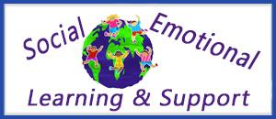
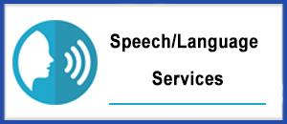
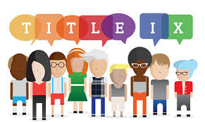

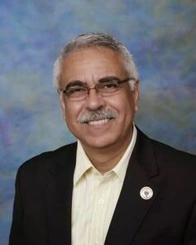 | MESSAGE FROM THE DIRECTOR OF SPECIAL SERVICES  Dr. Israel I. Koppisch  iikoppisch@aeetoledo.org  Tel: 419-382-2280
Dear Parents:

This monthly edition of our FAMILY MATTERS NEWSLETTER is focused in trying to help parents understand the scope of all the special education services and to help them determine the need for these services provided their children are encountering difficulties in their growth or learning patterns. I sincerely hope the following information will help you or any relative whose children might be struggling at school. We’ve tried to present you the information in an easy way to understand. Nevertheless, always feel free to contact our offices in order to help you analyze your specific concerns and situation. At AEE we are here to assist and support our families.
Cordially,
Dr. Israel I. Koppisch

Why is my child struggling in school?
When children are struggling in school, it’s important to find out why. It may be that a disability is affecting your child’s educational performance. If so, your child may be eligible for special education and related services that can help. To learn more about special education, keep reading so you can learn how you and the school can work together to help your child.

As a first step, the school may need to try sufficient interventions in the regular education classroom and modify instructional practices before referring your child for special education evaluation.

What is special education?

Special education is instruction that is specially designed to meet the unique needs of children who have disabilities. Special education and related services are provided in public schools at no cost to the parents and can include special instruction in the classroom, at home, in hospitals or institutions, or in other settings. This definition of special education comes from IDEA, the Individuals with Disabilities Education Act. This law gives eligible children with disabilities the right to receive special services and assistance in school.

More than 6.8 million children ages 3 through 21 receive special education and related services each year in the United States. Each of these children receives instruction that is specially designed to meet his or her unique needs (that result from having a disability); and to help the child learn the information and skills that other children are learning in the general education curriculum.

Who is eligible for special education?

Children with disabilities are eligible for special education and related services when they meet IDEA’s definition of a “child with a disability” in combination with state and local policies. IDEA’s definition of a “child with a disability” lists 13 different disability categories under which a child may be found eligible for special education and related services.
Autism Deafness
Deaf-blindness Hearing impairment
Intellectual disabilities Multiple disabilities
Orthopedic impairment Other health impairment
Serious emotional disturbance Traumatic brain injury
Speech/language impairment Specific learning disability
Visual impairment, including blindness

TO BE CONTINUED ON NEXT EDITION

MESSAGE
FROM THE INTERVENTION SPECIALIST
Margaret Hallett
mhallett@aeetoledo.org

Greetings Families!

Our professionals at AEE are continually observing your child. Our instructional staff or other professionals offering services at our school, may give your child written tests or talk personally with your child in order to determine their specific needs. They are trying to get a picture of the “whole child.” For example, they want to understand such aspects as:

- how well your child speaks and understands language;
- how your child thinks and behaves;
- how well your child adapts to changes in his or her environment;
- how well your child has done academically;
- how well your child functions in a number of areas, such as moving, thinking, learning, seeing, and hearing; and
- your child’s job-related and other post-school interests and abilities.

How does the school collect this information?
The school collects information about your child from many different people and in many different ways. Tests are an important part of an evaluation, but they are only a part. The evaluation should also include: the observations and opinions of professionals who have worked with your child; and your child’s medical history, when it relates to his or her performance in school; and your ideas about your child’s school experiences, abilities, needs, and behavior outside of school, and his or her feelings about school.

The following people will be part of the team evaluating your child:

You, as parents;
Your child, if appropriate;
At least one regular education teacher, if your child is or may be participating in the regular educational environment;
At least one of your child’s special education teachers or service providers;
A school administrator who knows about policies for special education, about children with disabilities, about the general education curriculum (the curriculum used by students who do not have disabilities), and about available resources;
Someone who can interpret the evaluation results and talk about what instruction may be necessary for your child;
Individuals (invited by you or the school) who have knowledge or special expertise about your child;
Representatives from any other agencies that may be responsible for paying for or providing transition services (if your child is age 16 or, if appropriate, younger and will be planning for life after high school); and
Other qualified professionals.

These other qualified professionals may be responsible for collecting specific kinds of information about your child. They may include:
- a school psychologist and/or an occupational therapist;
- a speech and language pathologist (sometimes called a speech therapist);
- a physical therapist and/or adaptive physical education therapist or teacher;
- a medical specialist; and others, if necessary.
Always remember—at AEE: we are here to assist you as a parent and help your child achieve his learning goals.

ALL CHILDREN CAN LEARN!
Sincerely,
Mrs. Margaret Hallett

WHAT CHALLENGES DOES YOUR CHILD EXPERIENCE?

Does your child have difficulties with day-to-day activities at home, school, or in the community? Do they experience challenges that do not affect most typically developing children? If so, an occupational therapist may be able to help your child. Occupational therapy is a treatment that supports a child and their family when they experience difficulties in the areas outlined below.

DEVELOPMENTAL DELAY

Developmental delay means that a child is behind in developing skills that are common during a particular age or during a particular time period. A developmental delay, however is more than being a little behind other child in a skill; it is being behind in a combination of skills or not meeting development milestones. These are examples of developmental delays:

- Not reaching developmental milestones of sitting, crawling, and walking
- Not learning at an age appropriate level
- Not developing age appropriate play and social skills

FINE MOTOR SKILLS

Fine motor skills are small movements made with fingers, toes, wrists, lips, and tongue, like holding a small object or picking up a spoon. If your child is struggling with fine motor skills, they may have difficulty with one of these actions:

- Manipulating toys and puzzles
- Holding a pencil
- Using silverware or straws at an age-appropriate time
- Using scissors
- Using zippers, buttons, shoelaces
- Coloring, drawing, tracing, prewriting shapes
- Poor handwriting, letter/number formation
- Not developing a hand dominance at an age-appropriate time
- Avoiding tasks and games that require fine motor skills

MOVEMENT, STRENGTH, & BALANCE DEVELOPMENT (GROSS MOTOR SKILLS)

Gross motor skills help us move and coordinate our arms, legs, and other body parts. They involve larger muscles that help us control our body. A child who is behind in movement, strength, and/or balance may appear clumsy or uncoordinated. They may also have difficulty with these things:
- Going up and down stairs at an age appropriate time
- Coordinating both sides of the body
- Understanding the concept of right and left
- Poor ball skills
- Poor balance
Their muscle tone, or muscle tension and resistance, could be higher or lower than the appropriate developmental milestone. They might also:
- be fearful of feet leaving the ground
- doesn't cross midline of his or her body during play and school tasks
- avoids tasks and games that require gross motor skills

VISUAL PROCESSING
Visual processing is the process we use to make sense of what we see. It is a process in our brain that interprets visual information. If your child has difficulty with one of these things, they may have difficult with visual processing:
- Difficulty with the spacing and sizes of letters
- Difficulty with recognizing letters
- Difficulty with copying shapes or letters
- Difficulty with visual tracking and crossing midline
- Difficulty finding objects among other objects
- Difficulty with copying from the board or another paper
- Difficulty with the concept of right and left
- Your child may lose his or her place when reading or copying from the board or may have poor eye contact.

ORAL MOTOR / ORAL SENSORY

Oral motor or oral sensory skills are control of muscle movements in the face and oral area, such as the lips, jaw, tongue, and soft palate. Delayed oral motor and sensory skills can show in one or more of these ways:

- Excessive drool
- Chews food in the front of the mouth, rather than on the molars
- Difficulty using a cup at an age-appropriate time
- Difficulty with drinking from a straw at an age-appropriate time
- Lengthy bottle or breast feedings
- Tiredness after eating
- Baby loses excessive liquid from his or her lips when bottle or breast feeding
- Child loses excessive liquid or food from his or her mouth when drinking or chewing
- Child appears to be excessively picky when eating, only eating certain types or textures of food
- Child excessively mouths toys or objects beyond an age-appropriate time

SENSORY PROCESSING

Sensory processing is making sense of information that we receive through our senses, like sound and smell. Your child may be oversensitive to things around them and show the following symptoms:

- Overly sensitive or heightened reactivity to sound, touch, or movement
- Under-responsive to certain sensations (e.g., high pain tolerance, doesn't notice cuts/bruises)
- Constantly moving, jumping, crashing, bumping
- Easily distracted by visual or auditory stimuli
- Emotionally reactive
- Difficulty coping with change
- Inability to calm self when upset

SOCIAL INTERACTION SKILLS

Social interaction skills are skills that help us have relationships and understand those around us. They help us bond with other people in our life. Your child may have delayed social skills if they show some of the following things:

- Difficulty interacting socially and engaging with family and peers
- Difficulty adapting to new environments
- Delayed language skills
- Overly focused on one subject (e.g., space, universe, dinosaurs, trains)
- Can't cope in the school environment

LEARNING CHALLENGES

Learning challenges, sometimes called learning disabilities, are another type of developmental delay. If your child is challenged by one of the following, you may want to consult an occupational therapist:

- Unable to concentrate and focus at school
- Easily distracted
- Difficulty following instructions and completing work
- Tires easily with school work
- Poor impulse control
- Hyperactivity or low energy
- Not keeping up with workload at school
- Difficulty learning new material
- Makes letter or number reversals after age seven

PLAY SKILLS

Play skills are skills that can help a child make sense of the world around them. A child can gain self-confidence, learn problem solving, and develop social skills through play. Your child may be developmentally delayed if they show one of the following symptoms:

- Needs adult guidance to initiate play
- Difficulty with imitative play
- Wanders aimlessly without purposeful play
- Moves quickly from one activity to the next
- Does not explore toys appropriately
- Participates in repetitive play for hours (e.g., lining up toys)
- Does not join in with peers/siblings when playing
- Does not understand concepts of sharing and turn taking

Remember that all children are different and develop these skill sets at their own pace. However, if you think your child may be struggling with adopting some of the skill areas above, you can contact us in order to assist you get in contact with an Occupational Therapist.

AEE- SPED Program provides a variety of services to support our children and families.

ACADEMY OF EDUCATIONAL EXCELLENCE
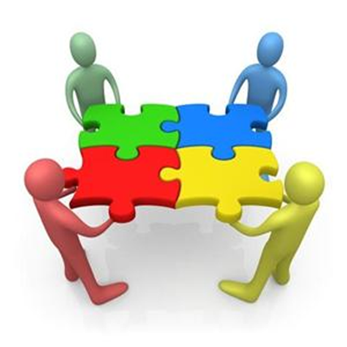
Department of Special Services - SPED Programs and Support Staff

Dr. Israel I. Koppisch
Director, Department of Special Services
Margaret Hallett, Intervention Specialist

Heather Dinklage, School Psychologist
Lauren Notestine, Speech and Language Therapist
XXXX, Occupational Therapist
Roye Durden, Licensed Social Worker / Behavior Specialist

