***HOME OF THE MIGHTY PENGUINS***  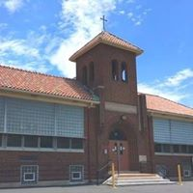[](http://paw-patrol.wikia.com/wiki/The_Penguins)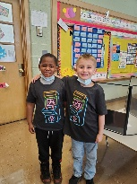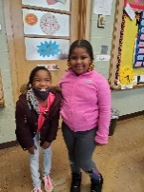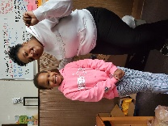

**MISSION**

*The mission of the Academy of Educational Excellence is to develop the whole child, allowing them to achieve their full academic potential, while preparing them for global leadership. This will be accomplished through rigorous mastery-focused curriculum including foreign languages, technology, enthusiastic teaching staff, and a caring involved community.*

Sponsor: North Central Ohio Education Service Center

**2020-2021 School Profile**

***AN ELEMENTARY LEADERSHIP and TECHNOLOGY SCHOOL***

***IRN-- 013195***

**Academy of Educational Excellence**

**TEAM OF EXCELLENCE**

**Sonya Loggins**

**Superintendent / School Leader**

**(Ann Harris –** *Superintendent*

*RIP- 02/08/2021)*

**Dr. Israel I. Koppisch**

*Director of Special Services: HR / SPED*

**Anita Bass**

*Registrar / EMIS Coordinator*

**STUDENTS K--6**

**Enrollment 108**

**Economically Disadvantaged 97.22%**

**Attendance rate: 83.22%**

**Black, Non-Hispanic 90.74%**

**Students with Disabilities 16%**

**GOVERNING BOARD**

**Charles Harrison** (2019-2022)

*President*

Allison Cox (2021-2024)

Beverly Tucker (2021-2024)

John Walthall (2019-2022)

Lena Webb (2019-2022)

Dr. James Jones (2019-2022)

Todd Johnson - Treasurer

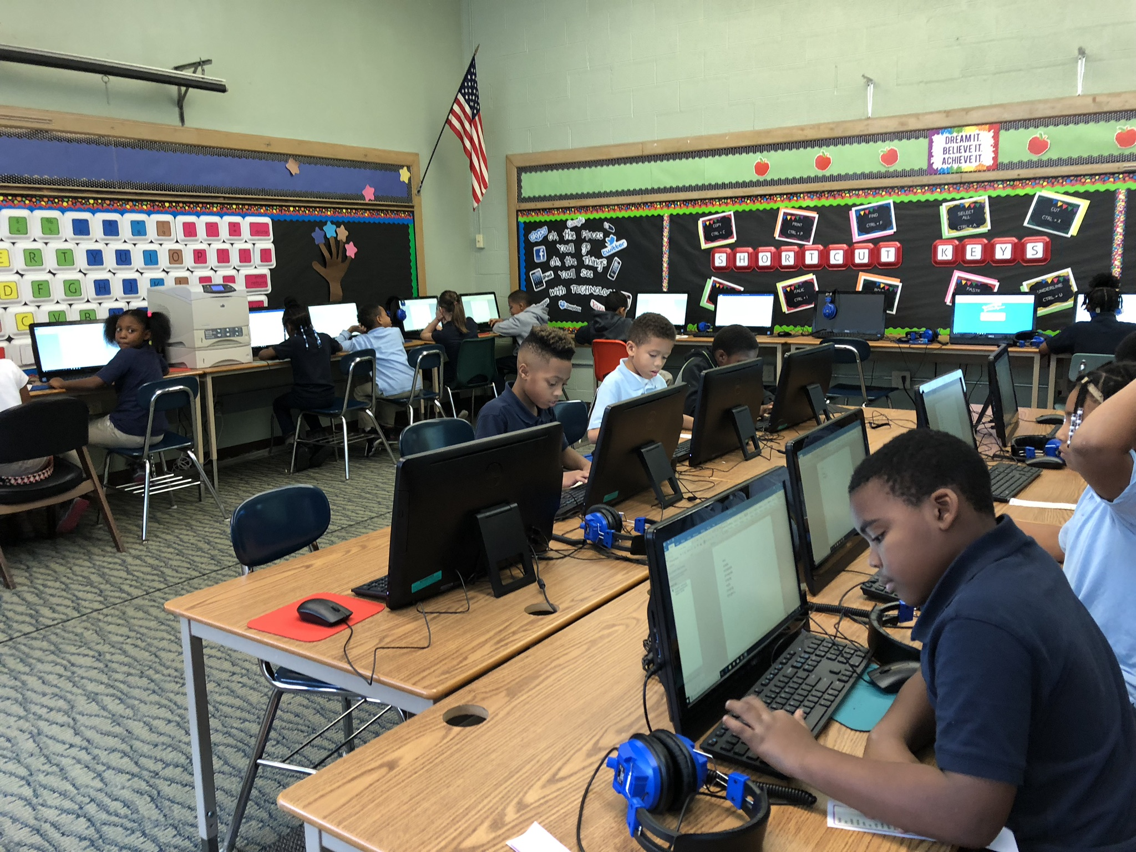

**ACADEMIC PERFORMANCE**

**Ohio Achievement Assessments**

**Third Grade Reading Guarantee requirements for promotion to the 4th grade— 100.0% Reading Proficient-- NR**

**Reading / Mathematics 4th -5th -6th grade- Science-5th grade—NR**

**FUNDING**

**Annual Income**

**$1,238,704.94**

**State Funds: $945,702.00 73.34%**

**Federal Funds: $293,002.00 23.65%**

**TOTAL EXPENDITURES: $1,483.930.36**

**Operating Spending per pupil: $15,457.00.**

**91% of funds spent on classroom instruction**

**Funds spent on non-classroom instruction: $14,065.87. (per pupil)**

**Non-Classroom Spending: $1,391. (per pupil)**

**Federal Funds: $5,032. (per pupil)**

**State and Local Funds: $9,858. (per pupil)**

**2015-2016 Fiscal Audit—No findings**

**2016-2017 Fiscal Audit—No findings**

**2017-2018 Fiscal Audit—No findings**

**2018-2019 Fiscal Audit—No findings**

**2019-2020 Fiscal Audit-- AUDITORS AWARD**

**2020-2021 Fiscal Audit- In Process**

**STUDENTS ENROLLED BY GRADES**

Kindergarten 21 19%

First Grade 18 17%

Second Grade 12 11%

Third Grade 19 18%

Fourth Grade 12 11%

Fifth Grade 11 10%

Sixth Grade 15 14%

TOTAL 108

**CURRICULUM HIGHLIGHTS**

* Reading: Success for All / Journeys / A to Z / RAZ Kids
* Math: EUREKA Math / MobyMax/ KHAN Academy
* Social Studies: McMillan Series
* Science: McMillan Series
* Additional offerings: Technology, The Leader in Me, Visual Arts,
* Positive Behavior Intervention Program
* Behavior Counseling

**ETHNIC SCHOOL COMPOSITION**

White 2 2 %

Black 92 90.74 %

Multiracial 14 6.48 %

Hispanic 2 2 %

**ODE REPORT CARD**

**Indicators Met: NR\***

**Performance Index: NR\***

**Value-added Overall: NR\***

**Students not state tested due to the COVID-19 pandemic**

**Poverty Status: 97.22%**

**Attendance Rate: 83.22%**

**Male Attendance Rate: 89.35%**

**Female Attendance Rate: 77.09%**

**AEE--Compliant with the federal requirement for implementing a local wellness policy.**

**TEACHER / STAFF**

1 Superintendent / School Leader

1 Director of Special Services

1 Registrar / EMIS Coordinator

1 Administrative Assistant

11 Teachers

3 Paraprofessionals

1 Intervention Specialist

3 Bus Drivers

1 Bus Aides

91% Teachers have at least BA Degree

9% Teachers have a Master’s Degree

90% Highly Qualified Teachers