FAMILY MATTERS EVERY CHILD. EVERY PARENT.

ACADEMY OF EDUCATIONAL EXCELLENCE 728 Parkside Boulevard, Toledo, Ohio 43607

A monthly newsletter from the Department of Special Services

VOL. 1 Issue 10 WORKING TOGETHER FOR FAMILY SUCCESS APRIL, 2021

Family Matters is an outreach effort from the Academy of Educational Excellence– Department of Special Services and its SPED Program. Family Matters will provide parents with information about special education and other resources available to assist them to help their children.

Mission Statement
The mission of the Academy of Educational Excellence special educators is to have an active partnership with all school personnel, students and the community. We will nurture individuals, who value themselves and others and provide an educational foundation that enables students to have the ability to think, communicate, create and apply their learning experiences throughout their lifetime.

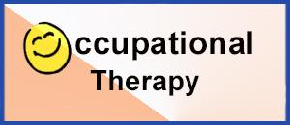
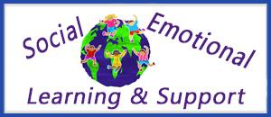
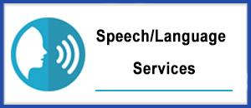
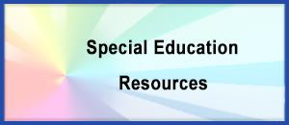
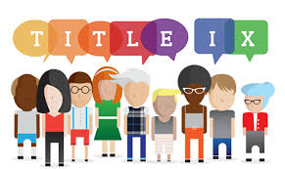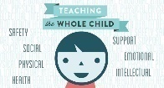

MESSAGE FROM THE DIRECTOR OF SPECIAL SERVICES  Editor—Family Matters Newsletter  Dr. Israel I. Koppisch  iikoppisch@aeetoledo.org  Tel: 419-382-2280 | 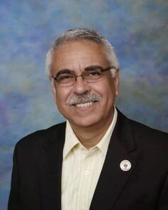
Dear Parents and Friends:

What do you imagine when you think about special education? You might picture children with disabilities spending the day tucked away in a different kind of classroom, separated from most of the kids their age. This may have been the norm in the past. But as the field of special education has moved forward, much has changed.
Special education today is still focused on helping children with disabilities learn. But this no longer has to mean placing kids in a special classroom all day long. In fact, federal law requires that students who receive special education services be taught alongside their non-disabled peers as much as possible.
For example, some students with dyslexia may spend most of the day in a general education classroom. They may spend just an hour or two in a resource room working with a specialist on reading and other skills. Other students with dyslexia might need more support than that. And others might need to attend a different school that specializes in teaching kids with learning disabilities.
Special education refers to a range of services that can be provided in different ways and in different settings. There is no “one size fits all” approach to special education. It’s tailored to meet each student’s needs. Special education refers to a range of services that can be provided in different ways and in different settings.

If your child qualifies for special education, your child will receive individualized teaching and other key resources at no cost to you. The specialist who work with your child will focus on your child’s strengths as well as challenges. And you’ll be an important member of the team that decides what your child needs to make progress in school.
The Individuals with Disabilities Education Act (IDEA) is the federal law that defines and regulates special education. The law requires public schools to provide special education services to children ages 3 to 21 who meet certain criteria.
To qualify for special education services, a student must:
- Have a documented disability that is covered by IDEA, and
- Need special education in order to access the general education curriculum
  - “Access” is an important term in education. Making the curriculum accessible to students with disabilities is a lot like making buildings accessible to people in wheelchairs. If there’s a barrier to your child’s learning, such as difficulty reading, the school needs to come up with the equivalent of a wheelchair ramp to help your child access the reading material.
At AEE we have a process in place to determine which students are eligible for special education. This process involves a comprehensive evaluation that looks at the way your child thinks. It also looks at other aspects of his development. You or your child’s can request an evaluation. If the district agrees to evaluate your child, the testing will be conducted at no cost to you.
On the other hand, by law, schools are required to provide special education in the least restrictive environment (LRE). This means the starting point for discussion should be the supports your child needs to succeed in a general education classroom. Schools have a special term for deciding to place a child in one type of classroom rather than another. Schools refer to this as “placement.” General education classrooms are the most common placement for kids with learning disabilities.

At the Academy of Educational Excellence, we use many strategies to help students receiving special education services succeed in general education settings. These strategies include:
- Assistive technology such as providing a laptop to help a student with a writing disability take notes in class.
- Accommodations such as seating the student near the teacher (and far from distractions) or allowing him to give oral reports instead of writing essays.
- Modifications such as reducing the amount of homework a student is assigned
- Paraprofessionals who serve as teachers’ aides helping students with various tasks such as taking notes and highlighting important information; assisting students comply with their behavior expectations, helping them to focus on their daily tasks.

Even with various supports and services, some students might not be able to keep up with the pace of a general education classroom. Here are some other possible placements:
Self-contained classroom: Some students may make more progress in a classroom that is only for students receiving special education services. A self-contained classroom is taught by a special education teacher and typically has far fewer students than a general education classroom. With a lower ratio of students to teachers, a self-contained classroom can offer more one-on-one teaching that is tailored to each student’s goals and objectives.
Self-contained classrooms are sometimes referred to as special classrooms. Some students may spend all day in self-contained classrooms. Other students may spend part of the day “mainstreamed” in general education classrooms such as for art and P.E.
Inclusion classroom: A third option that is popular at many schools is called an inclusion classroom. This type of classroom includes a mix of students who do and do not receive special education services. A special education teacher and a general education teacher share equal responsibility for teaching the class. They weave in lots of learning supports to help students with different learning styles and skill levels.

What do “related services” include?

Federal law allows schools to provide certain kinds of services that aren’t strictly educational but are needed so that students can benefit from special education. These are called related services.
For example, a child who has dysgraphia or dyspraxia may need one-on-one sessions with an occupational therapist to improve handwriting skills. Other examples of related services include:
- Mental Health Counseling for children and parents.
- Social work to provide support to children and families and assist in developing positive behavioral interventions.
- Speech-Language Therapy to improve communication skills that affect learning.
- Physical Therapy is provided by physical therapists who promote, maintain, or restore health through physical examination, diagnosis, prognosis, patient education, physical intervention, rehabilitation, disease prevention and health promotion. In most instances, the services can ca provided at school or at the therapist’s office.
- Occupational Therapy, also known as OT, focuses on helping perform daily tasks more easily. This type of therapy focuses on improving fine and gross motor skills in order to carry out specific day-to-day activities. The occupational therapist will also focus on making home or school environment more optimal for everyday life.
- Transportation to and from school and, in some cases, to and from extracurricular activities.

AT THE ACADEMY OF EDUCATIONAL EXCELLENCE

If your child qualifies for special education,
your child will receive individualized teaching and other key resources at no cost to you.

Related services may include one-on-one sessions with speech-language therapists and other kinds of specialists at no cost to you.
Happy Easter!
Dr. Israel Koppisch

AT AEE SPECIAL SERVICES DEPARTMENT:
WE WANT TO MAKE THE DIFFERENCE TO ALL OF OUR CHILDREN
Check us on our new website: www.academyofeducationalexcellence.org

As you explore our web pages, you will see that the Special Services Department at AEE involves many areas and student services. Our caring staff is dedicated to assisting all students achieve their highest potential. We are also here as a resource for our families—referrals, partnerships and problem-solving.
Whether you are a student, parent or family member, we hope you will find many resources available to you useful.

MESSAGE  FROM THE INTERVENTION SPECIALIST  Margaret Hallett  mhallett@aeetoledo.org | 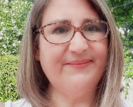
Greetings families!

As we approach the state testing months of April and May, our 3rd through 6th grade teachers are incorporating test prep lessons into their day. This is a time where students review all the things they covered so far this year and some learn a few new things along the way. In the previous months we talked about the importance of reading to your children, or have them read to help improve their vocabulary and build onto their current knowledge. We talked about how important it was to have them get a good night sleep, and to eat a healthy meal the night before and the morning of the State Test.

This month I want to focus on your and your child's mental health and the big picture. Yes, the State Tests are important and we want your child to do well, but it is also important to acknowledge that this has been a crazy pandemic school year. Our students had to transition their learning from virtual to in-house to virtual to in-house again. Our teachers had to teach in a whole new way that they have never taught before.

On the other hand, in a few weeks our AEE students will be taking the Ohio State tests. These are big test and they can be pretty scary. Everyone, teachers and students, have been working hard preparing for them despite a PANDEMIC! The people that work for the State of Ohio Department of Education will grade your test after you complete it and they will know how well you can find the main idea of an informational or literacy text and how to identify the supporting details. They will know if you know your vocabulary, your grammar, how well you write, your spelling, how well you know your grade level mathematics.

What they can’t see are the ways you helped your friends understand a concept, how you asked a new student if they will be your friend as you welcome them into your class. They can’t feel the uneasiness people felt about coming back to school for the first time in October. Making sure everyone is 6 feet apart, wearing a mask, eating cold sack lunches a lot, eating lunch in the classroom not in the cafeteria. They can’t see you stuck in your house being asked to try to figure out a new computer program, having the continual “munchies” but the refrigerator was not full. They can’t see family members you may have lost or how hard to was to focus on the teacher online while your siblings are playing in the background. How hard it was to make sure your assignment was actually turned in. Listening to the teachers asking “Can you hear me?” “Unmute yourself” or “Are you there?”

No matter what score you receive on your tests please remember you are a good friend, you are funny, you are hardworking, and you are the perfect you! This has been a hard year for everyone and it is important to allow yourself the grace to just be you.

Lots of love,
Mrs. Molly Hallett

ACADEMY OF EDUCATIONAL EXCELLENCE
Department of Special Services - SPED Programs and Support Staff

Dr. Israel I. Koppisch
Director, Department of Special Services
Editor—Family Matters Newsletter

Margaret Hallett
Intervention Specialist

Perris Loggins, Tutor
Hannah Jeffers, Paraprofessional

Heather Dinklage, School Psychologist
Lauren Notestine, Speech and Language Therapist
Ellie Braidic, Occupational Therapist
Beth Wymer, Physical Therapist
Roye Durden, Licensed Social Worker / Behavior Specialist

VISIT OUR NEW WEBSITE
www.academyofeducationalexcellence.org

