ANN JERKINS-HARRIS ACADEMY OF EXCELLENCE

728 Parkside Boulevard, Toledo, Ohio 43607

A monthly newsletter from the Department of Special Services

VOL. 2 Issue 01

WORKING TOGETHER FOR FAMILY SUCCESS AUGUST, 2021

www.ajhaee.org

FAMILY MATTERS
EVERY CHILD. EVERY PARENT.
Family Matters is an outreach effort from the
ANN JERKINS-HARRIS Academy of Excellence–
Department of Special Services and its SPED Program. Family Matters will provide parents with information about special education and other resources available to assist them to help their children.

SPED PROGRAM MISSION STATEMENT
The mission of the ANN JERKINS- HARRIS Academy of Excellence SPED Program is to create and maintain an effective learning environment by establishing behavioral supports and the social culture needed for all students in our school to achieve social, emotional, and academic success.

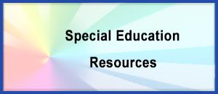
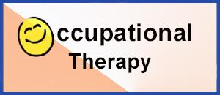
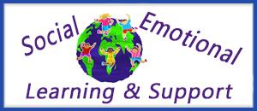
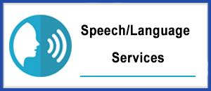
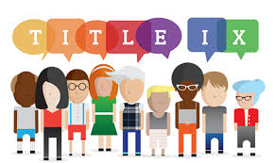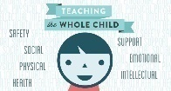

THE DIRECTOR’S CORNER  SPED PROGRAMS AND RELATED SERVICES  Editor—Family Matters Newsletter  Dr. Israel I. Koppisch  iikoppisch@aeetoledo.org  Tel: 419-382-2280 |  | 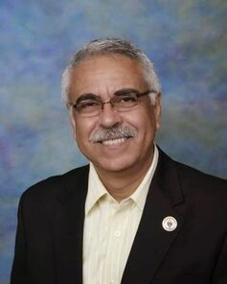
Dear Parents and Friends:
WELCOME BACK TO SCHOOL!!
SPECIAL EDUCATION: WHAT IS IT?

What do you imagine when you think about special education? You might picture children with disabilities spending the day tucked away in a different kind of classroom, separated from most of the kids their age. This may have been the norm in the past. But as the field of special education has moved forward, much has changed.  Special education today is still focused on helping children with disabilities learn. But this no longer has to mean placing kids in a special classroom all day long. In fact, federal law requires that students who receive special education services be taught alongside their non-disabled peers as much as possible.  For example, some students with dyslexia may spend most of the day in a general education classroom. They may spend just an hour or two in a resource room working with a specialist on reading and other skills. Other students with dyslexia might need more support than that. And others might need to attend a different school that specializes in teaching kids with learning disabilities.  Special education refers to a range of services that can be provided in different ways and in different settings. There is no “one size fits all” approach to special education. It’s tailored to meet each student’s needs. Special education refers to a range of services that can be provided in different ways and in different settings. | If your child qualifies for special education, your child will receive individualized teaching and other key resources at no cost to you. The specialist who work with your child will focus on your child’s strengths as well as challenges. And you’ll be an important member of the team that decides what your child needs to make progress in school.  The Individuals with Disabilities Education Act (IDEA) is the federal law that defines and regulates special education. The law requires public schools to provide special education services to children ages 3 to 21 who meet certain criteria.  To qualify for special education services, a student must:  - Have a documented disability that is covered by IDEA, and  - Need special education in order to access the general education curriculum  - “Access” is an important term in education. Making the curriculum accessible to students with disabilities is a lot like making buildings accessible to people in wheelchairs. If there’s a barrier to your child’s learning, such as difficulty reading, the school needs to come up with the equivalent of a wheelchair ramp to help your child access the reading material.

At the ANN JERKINS-HARRIS Academy of Excellence we have a process in place to determine which students are eligible for special education. This process involves a comprehensive evaluation that looks at the way your child thinks. It also looks at other aspects of his development. You or your child’s can request an evaluation. If the district agrees to evaluate your child, the testing will be conducted at no cost to you.  On the other hand, by law, schools are required to provide special education in the least restrictive environment (LRE). This means the starting point for discussion should be the supports your child needs to succeed in a general education classroom. Schools have a special term for deciding to place a child in one type of classroom rather than another. Schools refer to this as “placement.” General education classrooms are the most common placement for kids with learning disabilities.  At the ANN JERKINS-HARRIS Academy of Excellence, we use many strategies to help students receiving special education services succeed in general education settings. These strategies include:  - Assistive technology such as providing a laptop to help a student with a writing disability take notes in class.  - Accommodations such as seating the student near the teacher (and far from distractions) or allowing him to give oral reports instead of writing essays.  - Modifications such as reducing the amount of homework a student is assigned  - Paraprofessionals who serve as teachers’ aides helping students with various tasks such as taking notes and highlighting important information; assisting students comply with their behavior expectations, helping them to focus on their daily tasks.  Even with various supports and services, some students might not be able to keep up with the pace of a general education classroom. Here are some other possible placements:  Self-contained classroom: Some students may make more progress in a classroom that is only for students receiving special education services. A self-contained classroom is taught by a special education teacher and typically has far fewer students than a general education classroom. With a lower ratio of students to teachers, a self-contained classroom can offer more one-on-one teaching that is tailored to each student’s goals and objectives. | Self-contained classrooms are sometimes referred to as special classrooms. Some students may spend all day in self-contained classrooms. Other students may spend part of the day “mainstreamed” in general education classrooms such as for art and P.E.  Inclusion classroom: A third option that is popular at many schools is called an inclusion classroom. This type of classroom includes a mix of students who do and do not receive special education services. A special education teacher and a general education teacher share equal responsibility for teaching the class. They weave in lots of learning supports to help students with different learning styles and skill levels.  What do “related services” include?  Federal law allows schools to provide certain kinds of services that aren’t strictly educational but are needed so that students can benefit from special education. These are called related services.  For example, a child who has dysgraphia or dyspraxia may need one-on-one sessions with an occupational therapist to improve handwriting skills. Other examples of related services include:  - Mental Health Counseling for children and parents.  - Social work to provide support to children and families and assist in developing positive behavioral interventions.  - Speech-Language Therapy to improve communication skills that affect learning.  - Physical Therapy is provided by physical therapists who promote, maintain, or restore health through physical examination, diagnosis, prognosis, patient education, physical intervention, rehabilitation, disease prevention and health promotion. In most instances, the services can ca provided at school or at the therapist’s office.  - Occupational Therapy, also known as OT, focuses on helping perform daily tasks more easily. This type of therapy focuses on improving fine and gross motor skills in order to carry out specific day-to-day activities. The occupational therapist will also focus on making home or school environment more optimal for everyday life.  - Transportation to and from school and, in some cases, to and from extracurricular activities.

AT AJHAE SPECIAL SERVICES DEPARTMENT:
WE WANT TO MAKE THE DIFFERENCE TO ALL OF OUR CHILDREN
Check us on our new website: www.ajhaee.org

As you explore our web pages, you will see that the Special Services Department at AJAAE involves many areas and student services. Our caring staff is dedicated to assisting all students achieve their highest potential.
We are also here as a resource for our families—referrals, partnerships and problem-solving.
Whether you are a student, parent or family member, we hope you will find many resources available to you useful.

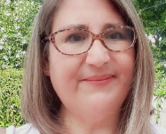

DIRECTLY TO YOU…
FROM THE INTERVENTION SPECIALIST
Margaret Hallett

AT THE ANN JERKINS-HARRIS ACADEMY OF EXCELLENCE
WE HAVE EXCEPTIONAL TEACHERS TEACHING EXCEPTIONAL CHILDREN

mhallett@aeetoledo.org

Greetings families,

My name is Molly Hallett, I’m the intervention specialist for the Ann Jerkins Harris Academy of Excellence. Among a diversity of responsibilities, I’m responsible to ensure all students from kindergarten to sixth grade are receiving interventions as noted on their Individual Education Plan (IEP); keeping the special education paperwork up-to-date; provide open communication with families, administration, and general education teachers; ensure that all accommodations and/or modifications are provided within the classrooms; coordinate meetings for new IEPs and ETRs; schedule speech and occupation therapy sessions when needed; progress monitor interventions to track successful teaching strategies and student learning, grade lessons, and write lessons for interventions. I provide small group and one on one lessons for students in the 4th through the 6th grade.

We have a wonderful team to help the SPED Department make this year run smoothly. Ms. Perris Loggins will provide interventions for grades kindergarten to third, reporting results to me. Ms. Shiloh Bass and Ms. Marie Zanders will be providing one-on-one assistance to students that require one. Ms. Hanna Jeffers will be working with the Principal and the general education teachers to provide in-class interventions for students that are not on the SPED caseload.

If you ever have any questions throughout the year, I would love to hear from you. You can contact me at mhallett@aeetoledo.org.

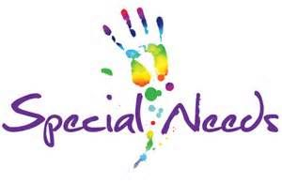

At a Glance
- Special education refers to a range of services that help kids with disabilities learn.
- It’s not a “one size fits all” approach — special education is tailored to meet the needs of individual kids.
- Kids who qualify for special education have an IEP.

Special education refers to a range of services that can be provided in different ways and in different settings. There’s no “one size fits all” approach to special education. It’s tailored to meet the needs of students with disabilities.
Special education focuses on helping kids with disabilities learn. But it doesn’t mean placing kids in a special classroom all day long. In fact, federal law says that kids who get special education services should learn in the same classrooms as other kids as much as possible. This is known as the least restrictive environment (or LRE).
The services and supports for one student may be very different from those of another student. It’s all about the individual child and giving them the resources they need to make progress in school.
For example, some students may spend most of the day in a general education classroom. Others may spend just an hour or two in a resource room working with a specialist. And others might need to attend a different school that specializes in teaching kids with learning disabilities.
Kids who qualify for special education have an Individualized Education Program (IEP). They get individualized teaching and other resources at no cost to their families. Specialists work with kids on strengths as well as challenges. And families are key members of the team that decides what kids need to thrive in school.

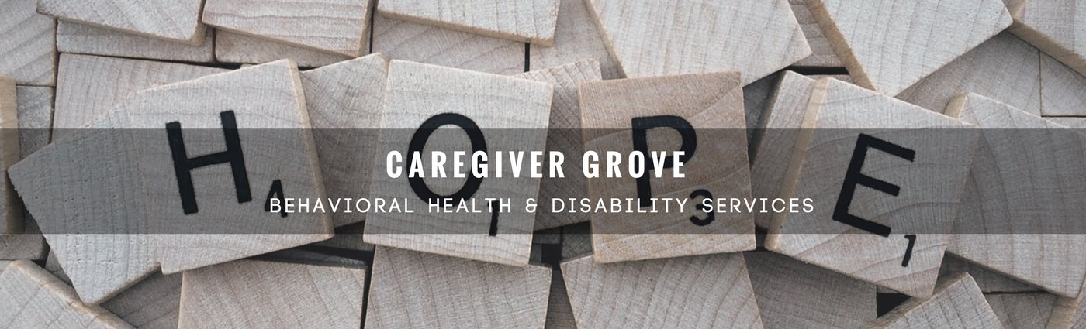
ANN JERKINS-HARRIS ACADEMY OF EXCELLENCE
(formerly Academy of Educational Excellence)
Department of Special Services - SPED Programs and Support Staff
FAMILY MATTERS COMMUNITY OUTREACH PROGRAM

Dr. Israel I. Koppisch  Director, Department of Special Services  SPED Program and Related Services  Editor—Family Matters Community Outreach Newsletter  Margaret Hallett  Intervention Specialist  TBD, Tutor-Teacher  Hannah Jeffers, Paraprofessional  TBD – Support Staff  Marie N. Zanders –Support Staff  Chinnon Jaquay, School Psychologist  Lauren Notestine, Speech and Language Therapist  Ellie Braidic, Occupational Therapist  Beth Wymer, Occupational Therapist  TBD—Physical Therapist  Roye Durden, Licensed Social Worker / Behavior Specialist  TBD, Licensed Social Worker / Behavior Specialist  Taylor Smith, Case Manager  TBD, Case Manager | 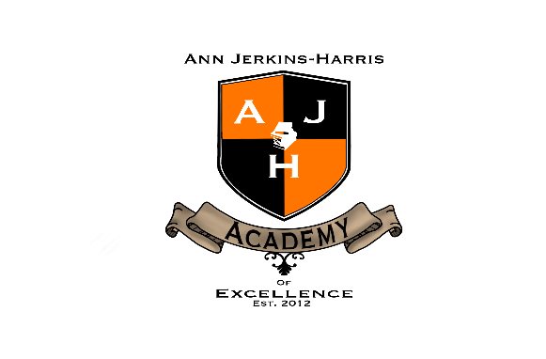
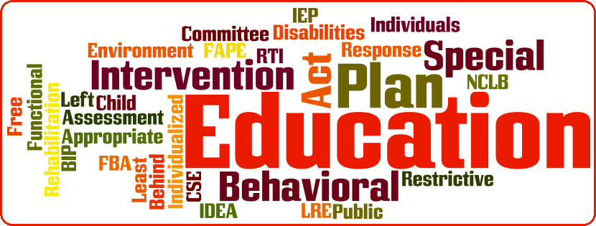

VISIT OUR NEW WEBSITE
SPED PAGES

www.ajhaee.org

SUPPORTING AGENCIES TO OUR SPED PROGRAM
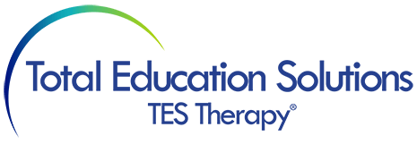

Northwest Ohio Speech and Language Rehabilitation Services
Speech Pathology | Occupational Therapy | Physical Therapy | Psychology

