SCHOOL POLICY:
Best Practices for Implementing Effective Hygiene and Social Distancing at AEE
Concepts based on Ohio COVID-19 Prevention Guidance for K-12 Schools and the CDC recommendations
Abstract
During the evolving COVID-19 pandemic, community mitigation strategies, such as social distancing, can slow down virus transmission in schools and surrounding communities. To date, research on school practices to promote social distancing in primary and secondary schools has focused on prolonged school closure, with little attention paid to the identification and feasibility of other more sustainable interventions. During communicable disease outbreaks such as the coronavirus pandemic, social distancing interventions that increase the space between people and decrease the frequency of contacts can play an important role in implementing effective hygiene practices in order to reactivate school operations.

“Empowering Students to Become Leaders in a Changing World”

SCHOOL POLICY:
Best Practices for Implementing Effective Hygiene and Social Distancing at AEE
Concepts based on Ohio COVID-19 Prevention Guidance for K-12 Schools and the CDC recommendations
Approved by AEE Governing Board on June 20th, 2020

Our lives have changed drastically over the last few months as the state, the country, and the world deals with the novel coronavirus. In that time, thousands of Ohioans have contracted the illness, schools and businesses have been forced to close for weeks on end and unemployment numbers have skyrocketed. Nearly six months into Ohio's response, the state is slowly starting the process of re-opening areas of the economy—including our schools.

TARGET:

Using existing furniture to increase physical distancing and school safety.
Adding personal protective equipment (PPE) and distancing products to school operations.
Revising furniture choices for new construction.
Establish general school operations plan under COVID-19.
Develop teaching-learning model according to COVID-19 guidelines.

The Ohio Public Health Advisory System will provide local health departments and community leaders data and information to combat flare-ups as they occur in different parts of the state. The system consists of four levels that provide Ohioans with guidance as to the severity of the problem in the counties in which they live. According Governor DeWine: "Our new Public Health Advisory System will help make clear the very real dangers happening in individual counties across Ohio". "This is a color-coded system built on a data-driven framework to assess the degree of the virus’ spread and to inform, engage, and empower individuals, businesses, communities, local governments, and others in their response and actions."

Data Indicators:
A county's alert level is determined by seven data indicators:
- New Cases Per Capita
- Sustained Increase in New Cases
- Proportion of Cases that Are Not Congregate Cases
- Sustained Increase in Emergency Room Visits
- Sustained Increase in Outpatient Visits
- Sustained Increase in New COVID-19 Hospital Admissions
- Intensive Care Unit (ICU) Bed Occupancy

ALERT LEVELS

ALERT LEVEL 1  PUBLIC EMERGENCY | ALERT LEVEL 2  PUBLIC EMERGENCY | ALERT LEVEL 3  PUBLIC EMERGENCY | ALERT LEVEL 4  PUBLIC EMERGENCY
Baseline level. County has met zero or one indicator. Active exposure and spread. Follow all current health orders. | Increased exposure and spread.  Exercise high degree of caution. Follow all current health orders. | County has met four or five indicators. Very high exposure and spread. Limit activities as much as possible. Follow all current health orders. | County has met six or seven indicators. Severe exposure and spread. Only leave home for supplies and services. Follow all current health orders.
- Conduct a daily health/symptom self-evaluation and stay home if symptomatic.  - Maintain social distancing of at least 6 feet from non-household members.  - Wear face coverings in public especially when social distancing is difficult to maintain.  - Increase caution when interacting with others not practicing social distancing or wearing face covers.  - Avoid traveling to high-risk areas.  - Follow good hygiene standards, including:  - Wash hands frequently with soap and water for at least 20 seconds.  - Use hand-sanitizer frequently.  - Avoid touching the face.  - Cover coughs or sneezes (e.g., into a tissue, or elbow).  - Symptom self-evaluation monitoring. | - Same guidelines as in Level 1.  - Avoid contact with anyone who is considered high-risk.  - High-risk individuals should take extra care to follow precautions.  - Decrease in-person interactions outside household.  - Seek medical care as needed, but limit or avoid unnecessary visits to hospitals, nursing homes, and residential care facilities to see others as much as possible. | - Same guidelines as in Levels 1-2.  - Decrease in-person interactions with others.  - Consider necessary travel only.  - Limit attending gatherings of any number. | - Same guidelines as in Level 1-3.  - Stay at home / necessary travel only.
LEVEL 1—4 REQUIRE COMPLIANCE WITH ALL HEALTH ORDERS

GENERAL GUIDELINES

- Keep school emergency plans updated.
- Teach / reinforce healthy hygiene practices both to employees and students.
- Ensure adequate provision of supplies in school—at all times.
- Intensify disinfection efforts of school facilities:

  - Minimum Expectations:
    - Wear facial masks at all times.
    - Wash hands frequently / use hand sanitizers
    - Avoid touching the face.
    - Temperature check—at least once a day.
    - Implement multiple social distancing strategies:
        - Six feet social distancing.
        - Banning physical contact
        - Cancel any large gathering or classes requiring close contact
        - Increase space between desks
        - Avoid common area missing
        - Stagger arrival / dismissal times
        - Ban non-essential visitors to school facilities

- Implement extended virtual learning or continuity of education
- Ensure continuity of meal programs
- No parents or non-essential people allowed in the school
- Asking older and immune-compromised people to stay home
- Having teachers move to new classrooms at bell change versus students

HEALTH GOALS
MINIMUM EXPECTATIONS AND BEST PRACTICES FOR EVERYONE AT AEE

All those in the school building will be required to:
- Wear masks, preferably their own cloth masks
- Wash hands frequently and/or use hand sanitizer
- Avoid touching the face
- Maintain a 6-foot distance whenever feasible
- Get their temperature checked at least once a day, either at home or school
- Self-report that they have symptoms that need to be evaluated

Social Distancing:

- Marking the floor to facilitate distancing.
- Use tabletop partitions / desk partitions.
- Use cafeteria as temporary classrooms—if necessary.

Sanitation / Health:

  - Temperature checks to enter the building and/or when transported in the school buses. Any student who presents to have a temperature above 100`F will NOT be allowed to step-in the bus.
  - Any student or staff member presenting to have a temperature above 100`F must be immediately separated from other students or staff members, given a face covering, and monitored by a staff member wearing appropriate personal protective equipment (PPE) and maintaining physical distance when possible.
  - School personnel will refer those displaying symptoms of COVID-19 to an appropriate health care professional or testing sites.
  - Sanitizing clothes and footwear before entering the building.
  - Ventilating areas by opening windows and doors.
  - Practice handwashing for at least 20 seconds when hands are dirty, before and after eating, and after using the restroom.
  - Supplement handwashing with hand sanitizer (60-95% alcohol based) in traffic areas including entrances and classrooms, and instruct students and staff members to use sanitizer.
  - Mandatory wiping down of furnishings and equipment.
  - Cleaning door handles and toilet seats at least twice daily.
  - Staff and students should avoid touching their noses, mouths, and eyes since the virus easily enters the body through these membranes.

Guiding Principles to Keep in Mind
The more people a student or staff member interacts with, and the longer that interaction, the higher the risk of COVID-19 spread. The risk of COVID-19 spread increases in school settings as follows:
- Lowest Risk: Students and teachers engage in virtual-only classes, activities, and events.
- More Risk: Small, in-person classes, activities, and events. Groups of students stay together and with the same teacher throughout/across school days and groups do not mix. Students remain at least 6 feet apart and do not share objects (e.g., hybrid virtual and in-person class structures, or staggered/rotated scheduling to accommodate smaller class sizes).
- Highest Risk: Full sized, in-person classes, activities, and events. Students are not spaced apart, share classroom materials or supplies, and mix between classes and activities.

COVID-19 is mostly spread by respiratory droplets released when people talk, cough, or sneeze. It is thought that the virus may spread to hands from a contaminated surface and then to the nose or mouth, causing infection. Therefore, personal prevention practices (such as handwashing, staying home when sick) and environmental cleaning and disinfection are important principles that are covered in this document. Fortunately, there are a number of actions school administrators can take to help lower the risk of COVID-19 exposure and spread during school sessions and activities.

COVID-19 SYMPTOMS

An individual may have COVID-19 if they are experiencing one or more of the following:

• Fever or chills • Cough • Shortness of breath or difficulty breathing
• Fatigue • Muscle or body aches
• Headache • Loss of taste or smell • Sore throat
• Congestion or runny nose • Nausea or vomiting • Diarrhea

SYMPTOMS RANGE FROM MILD TO SEVERE AND MAY APPEAR TWO TO 14 DAYS AFTER EXPOSURE TO THE VIRUS.

- If a student, staff, or volunteer begins to show symptoms or has a temperature above 100°F while at school, they must immediately be separated from other students, staff, or volunteers, given a face covering, and monitored by a staff member wearing appropriate personal protective equipment (PPE) and maintaining physical distance when possible.

- The space where an individual waits before he or she goes home should be separate from the nurse’s office and other areas students are likely to visit.

- Areas of the building that were occupied by a person exhibiting symptoms should be thoroughly sanitized.

- School personnel must refer those displaying symptoms of COVID-19 to an appropriate health care professional or testing sites.

- Local health departments should be contacted in the case of positive or suspected COVID-19 cases in a school building.

- Local health professionals can help to identify potentially infected or exposed individuals and assist with appropriate notifications.

- Individuals who potentially have been exposed should follow quarantine and other recommendations from local public health officials and their medical provider.

- Schools must monitor daily absences of students and staff for trends.

- Staff, volunteers, support workers, and students who have suspected or confirmed COVID-19 cannot return to school until they meet CDC criteria for return to work/school, and districts should be prepared with appropriate plans for absences.

- Individuals who test positive for or are suspected to have COVID-19 must experience an improvement in symptoms and isolate for a period of time before returning to school.

GENERAL GUIDELINES AND PROCEDURES

School Bus Practices

New needs for the process: Temperature screening Social distancing

Ideas for the new solution:

- Screen students for temperature with parent’s present before entering the bus.
- Any student who presents to have a temperature above 100`F will NOT be allowed to step-in the bus or come to school.
- Fill the bus from the back
- Fill one child to a window seat
- Children from the same family can sit together
- Exit front-to-back

Entryways & Hallways

New needs for the space:
Limit hallway traffic
Establish traffic flow
Clear walkways with defined traffic flow
Excess furniture removed Well-spaced furnishings

Teachers move instead of students:

- Teachers move, students stay in classrooms
- Classroom storage rather than lockers
- Custodians wipe down door handles and stairwells between classes

Drop-off Area Practices

A staff member will be allocated on the dropping-off area:
Temperature screening
- Any student who presents to have a temperature above 100`F will NOT be allowed to enter school.
Sanitize clothes, shoes and hands
Establish social distancing Direct students to areas

Ideas for the new solution:

- Wait for staff to let out students
- Multiple entry/exit points (consider color coding)
- Hand sanitizer and temperature screeners at entry points
- Stickers to show proper check-in after temperature screening
- Consider facial recognition for attendance
- Gated movement inside and outside the building

Classrooms Practices

New needs for the space:
Maximize distance & maintain hygiene

Ideas for the new solution:

- Remove excess furniture from student spaces
- Minimize direct face-to-face seating arrangements
- Use desks for personal storage
- Classrooms double as dining areas
- Hand sanitizer for each student
- Accessible sanitizing stations around the room
- Wipe down furniture and equipment between classes
- UV disinfection wands and cabinet storage for shared items
- Door and window ventilation
- Wide spacing between desks
- Desks with personal storage
- Wide walkways
- Access to sanitizing stations and supplies
- Partitions at high interaction areas
- Zig-zag storage on shelves
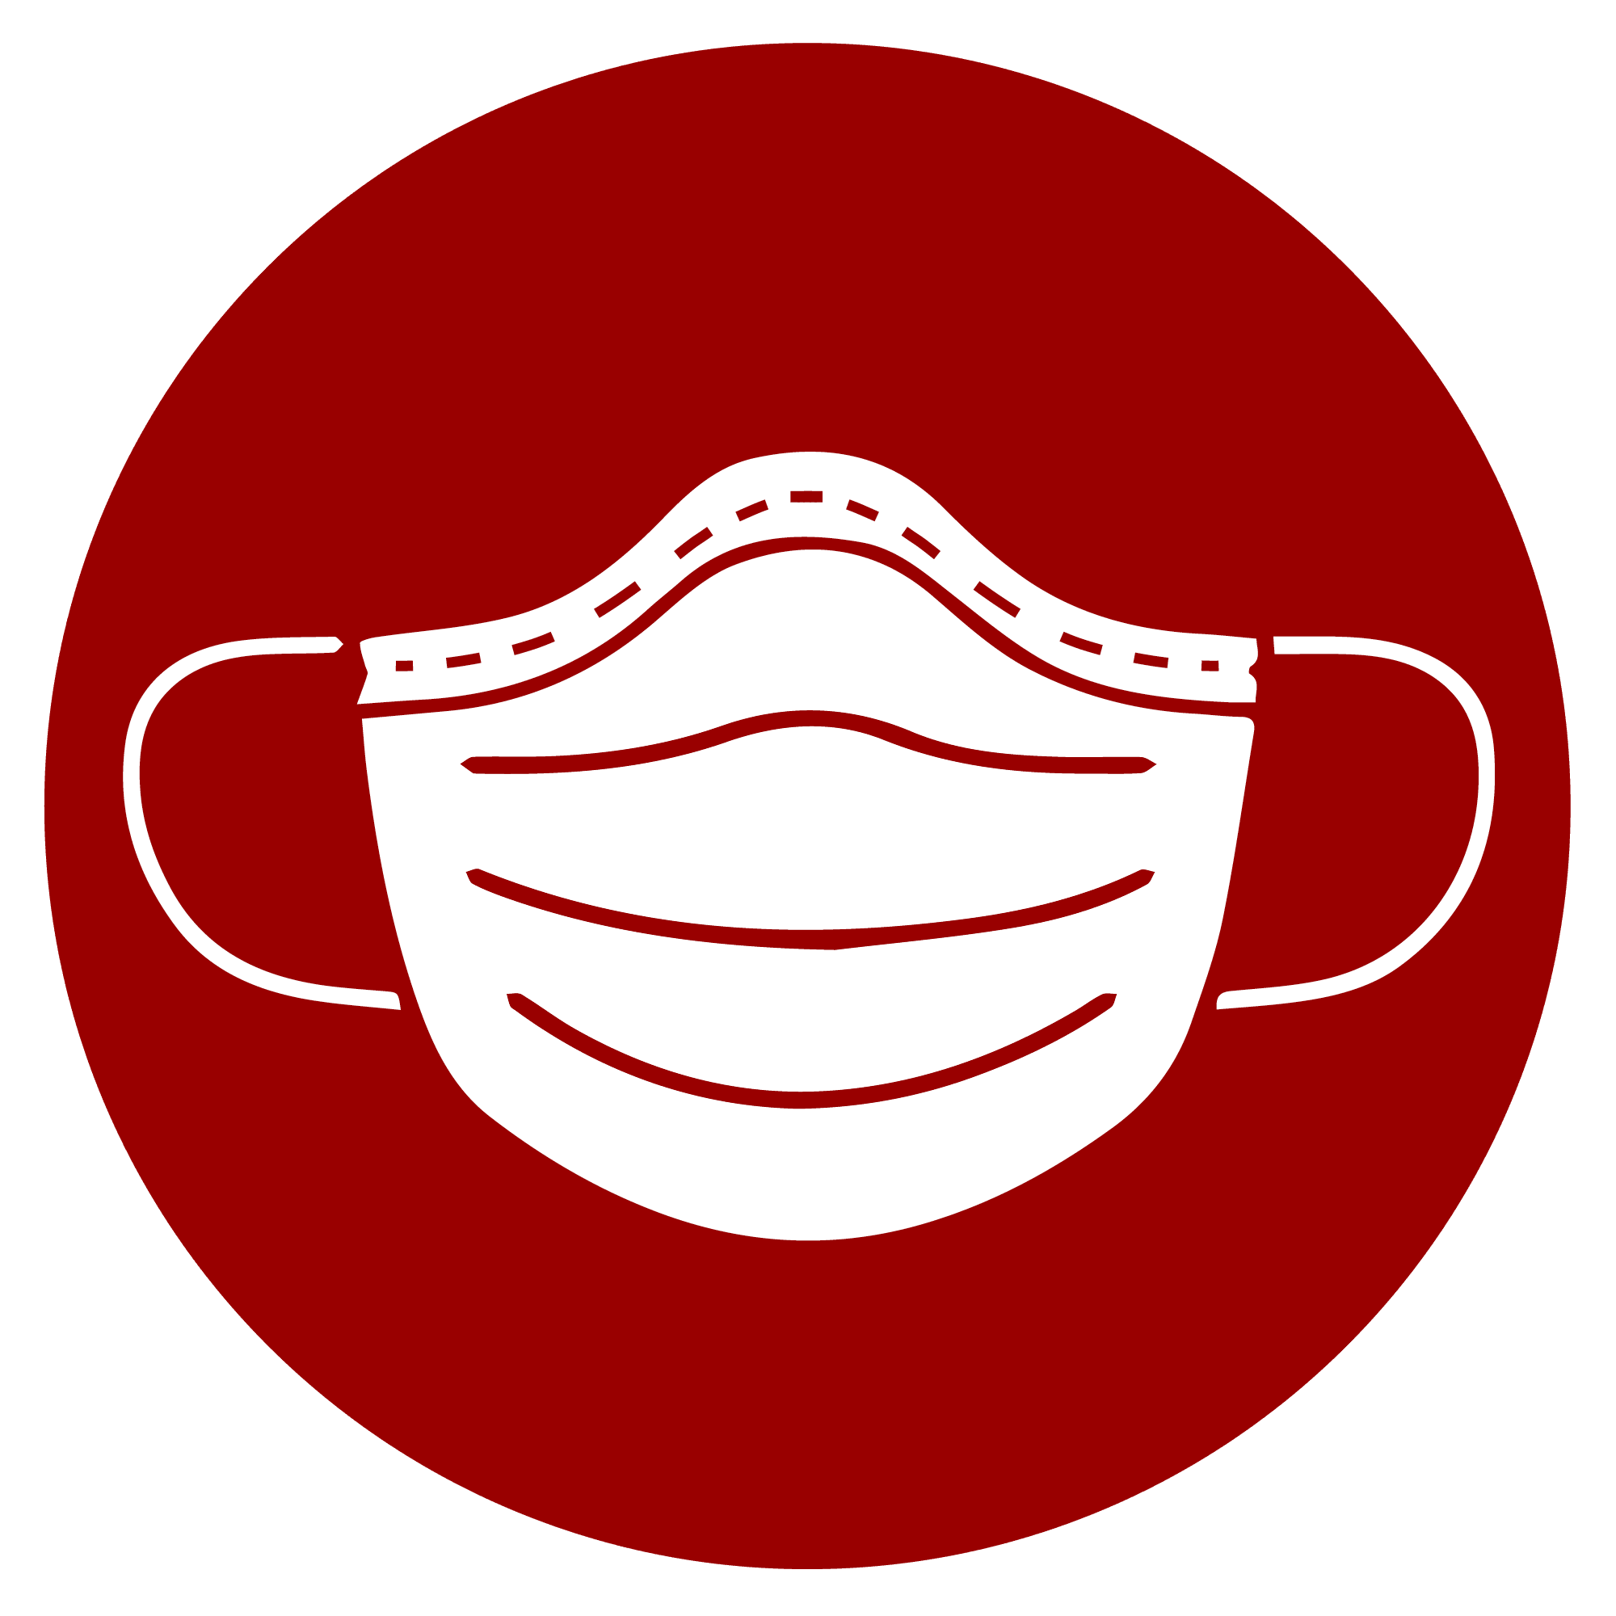

Restroom Practices
New needs for the space:
Social distancing and hygiene

Ideas for the new solution:
- Schedule for classes to access restroom
- Monitor traffic for non-scheduled restroom traffic
- Full length privacy panels at open toilet fixtures or block usage at every-other toilet
- Signs for proper hand washing
- Constant supply of soap, hand sanitizer and paper towels
- Hands-free soap dispensers
- Regular cleaning of high-touch surfaces

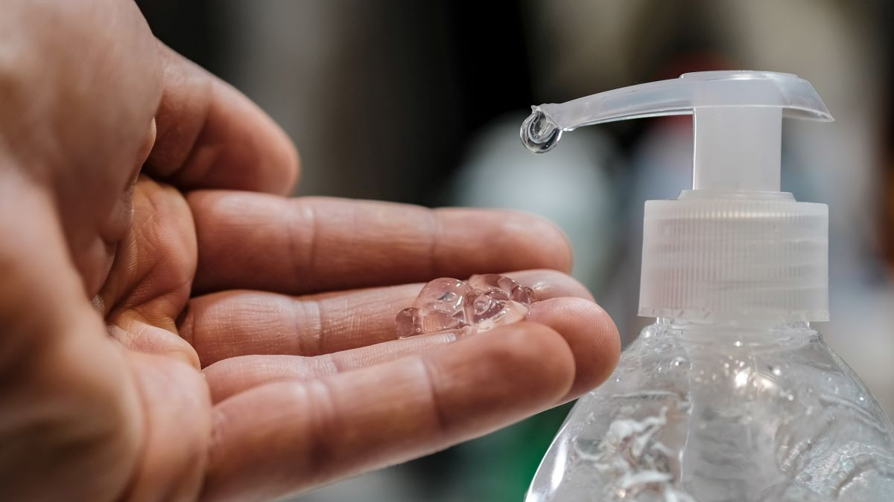
Practice Social Distancing
Keeping a distance of six feet or more between people adds another layer of prevention against the spread of COVID-19 by minimizing the chance of coming into contact with the virus through respiratory droplets. Distancing of six feet or greater is key in preventing droplet spread when speaking loudly, singing, or playing a musical instrument, which have been connected to increased respiratory droplet spread.
- School staff should try when possible to maintain 6-foot distance among students and staff in all school environments, including classrooms, hallways, restrooms, cafeteria, playground area, drop-off and pick-up locations, and school buses. Where social distancing is difficult, face coverings are mandatory.
- Reinforce social distancing with visual cues such as floor markings and signs.
- Avoid using shared materials or shared spaces.
- Reduce student groups.
- Eliminate filed-trips.
Stairways Practices
New needs for the space: Social distancing Sanitation and hygiene

Ideas for the new solution:

- Tape off “up” and “down” lanes
- Monitor for “2-stair distance” between students
- Frequent cleaning of railing and walls
Food Service Practices
New needs for the space: Social distancing Food safety

- Safest option: Individual breakfast and lunches prepacked and delivered to classrooms
- Hand sanitizer at entries, exits and at tables
- Use cafeteria as temporary classrooms and holding areas, when needed.

Adapted Cafeteria for Distancing and Sanitation

- Zigzag seating at every other seat
- Guards on tabletops and between sections
- Individualized meals or designated food handlers
- Many accessible handwashing/ sanitizing stations
- Guards for lunch-attendance keepers

Common Areas Practices

New needs for the space: Social distancing & sanitation

Ideas for the new solution:

- Potentially repurpose for monitored study or classes
- Potential sign-ups for limited capacity use
- Remove cozy group furniture or prohibit group use
- One seat per small group table
- Stations or partitions to create sections
- Mandatory wiping down surfaces after student use
- Hand sanitizer and wipes readily accessible

Technology Lab Work Practices

New needs for the space:
Social distancing & sanitation
More individual lab and project work

Ideas for the new solution:

- Regulate traffic patterns to computer stations
- Maintain consistent small groups for team projects
- Frequent wipe-down of surfaces after use
- Potential sign-up sheet for limited capacity use
- Limit seating to maintain 6-foot distance
- Computer keyboards are to be sanitized after use by any person.
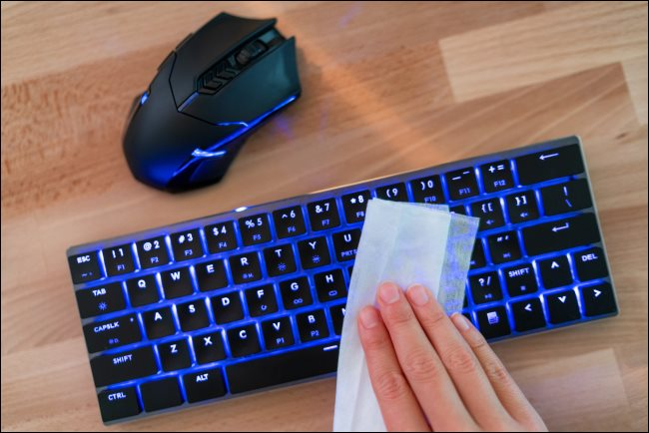

Adaptations
Music Room -Large Group Space Practices

New needs for the space:
Social distancing
Facilitating physical effort while maintaining
health

Ideas for the new solution:

- Use of school cafeteria to meet with music classes / Drumlines
- Practicing in sections rather than in whole groups
- Creating activities that don’t require proximity
- Creating activities that make use of individual equipment (e.g., hockey sticks, individual music folders)
- Outdoor practices and participation
- Mutes or coverings on instruments that reduce particulates in the air
- Potentially repurpose for classrooms or holding areas
- Reduce seating to particular sections
- Spread out seats within each section
- Ready access to sanitizer
- Front facing seating arrangements

Adaptations | Outdoor Spaces Practices

New needs for the space:
Social distancing
Lifting mood via movement and fresh air

Ideas for the new solution:
- Sectioning the playground with paint or weather resistant tapes
- Individual games that can be enjoyed with others (e.g., hopscotch)
- Group games that don’t require close contact or equipment that needs to be picked up (e.g., Simon Says, Red Light/Green Light)
- Group exercise
- Consider allowing devices during recess
- Consider using outdoors for classrooms
- Sanitize hands and equipment before and after outdoor time

Administrative Offices Practices

New needs for the space:
Protect staff and students from airborne particles
Social distancing & sanitation

Ideas for the new solution:

- Wearing masks at shared office areas
- Clear acrylic screens on countertops and/or front of desks
- Spacing between chairs in waiting area
- Access to hand sanitizer throughout the day

Front Office with Reception and Waiting Area

- Polyglass on shared counter space
- Divided seats in waiting area
- Front facing waiting area seating arrangements
- Ready access to sanitizer

Adaptations | Dismissal Practices

New needs for the process:
Regulate traffic flow out of the building
Social distancing

Ideas for the new solution:

- Consider grouping students into walkers, bus riders and pick-ups
- Consider the order for releasing students by group
◦ Walkers could be released first because they don’t have to wait on anyone
◦ Consider releasing students every 3 seconds
◦ Consider publishing a time schedule for pick-ups with a hotline for absolutely, unavoidable emergencies

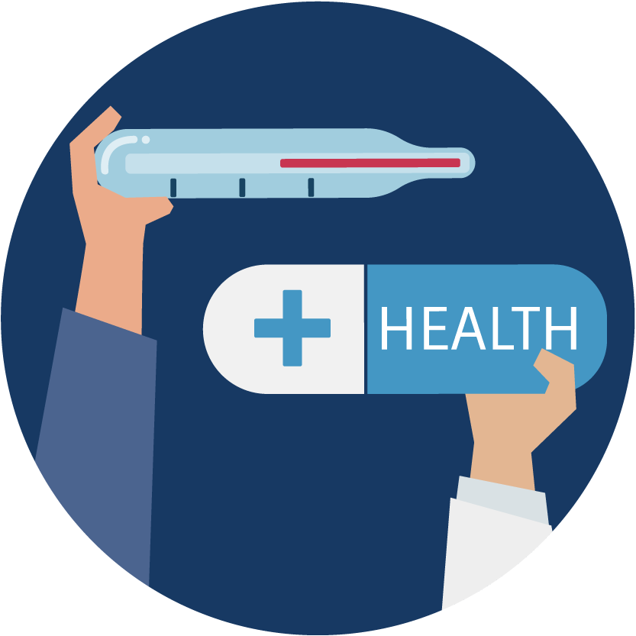

Sick Room Practices

New needs for the process:
Temperature screening Contact parents Social distancing

Ideas for the new solution:

If any student and/or staff member have a fever, cough or other symptoms, they might have COVID-19. Most people have mild illness and are able to recover at home.

Separate sick person from other people. As much as possible, keep sick person in a specific room and away from other people. Sick room will be located in the basement (next to cafeteria). If possible, they should use a separate bathroom.

When to Seek Emergency Medical Attention

Look for emergency warning signs* for COVID-19. If someone is showing any of these signs, seek emergency medical care immediately:
- Trouble breathing
- Persistent pain or pressure in the chest
- New confusion
- Inability to wake or stay awake
- Bluish lips or face
*This list is not all possible symptoms. Please call parents of any student with possible symptoms.
Call 911 or call ahead to local emergency facility:
Notify the operator that you are seeking care for someone who has or may have COVID-19.

Preparing for When Someone Gets Sick

The school will consider implementing several strategies to prepare for when someone gets sick.
- Advise Staff and Families of Sick Students of Home Isolation Criteria

Sick staff members or students should not return until they have met local health or CDC’s criteria to discontinue home isolation.

- Isolate and Transport Those Who are Sick

  - Make sure that staff and families know that they (staff) or their children (families) should not come to school, and that they should notify school officials (e.g., the designated COVID-19 point of contact) if they (staff) or their child (families) become sick with COVID-19 symptoms, test positive for COVID-19, or have been exposed to someone with COVID-19 symptoms or a confirmed or suspected case.
  - Immediately separate staff and children with COVID-19 symptoms (such as fever, cough, or shortness of breath) at school. Individuals who are sick should go home or to a healthcare facility depending on how severe their symptoms are, and follow CDC guidance for caring for oneself and others who are sick.
  - Work with school administrators, nurses, and other healthcare providers to identify an isolation room or area to separate anyone who has COVID-19 symptoms or tests positive but does not have symptoms.
  - Establish procedures for safely transporting anyone who is sick to their home or to a healthcare facility. If you are calling an ambulance or bringing someone to the hospital, try to call first to alert them that the person may have COVID-19.

- Clean and Disinfect

  - Close off areas used by a sick person and do not use these areas until after cleaning and disinfecting
  - Wait at least 24 hours before cleaning and disinfecting. If 24 hours is not feasible, wait as long as possible.
  - Ensure safe and correct use and storage of cleaning and disinfection products, including storing products securely away from children.

- Notify Health Officials and Close Contacts

  - In accordance with state and local laws and regulations, school administrators should notify local health officials, staff, and families immediately of any case of COVID-19 while maintaining confidentiality in accordance with the Americans with Disabilities Act (ADA)external icon.
  - Inform those who have had close contact with a person diagnosed with COVID-19 to stay home and self-monitor for symptoms, and follow CDC guidance if symptoms develop.

DAILY ATTENDANCE MONITORING

AEE teachers and administrators will monitor daily attendance of students and staff for trends. Importantly, sick leave and absence policies will not penalize staff or students for staying home when symptomatic or in quarantine or isolation.

Staff members, support workers, and students who have suspected or confirmed COVID-19 cannot return to school until they meet Health Department and CDC criteria for return to work/school.

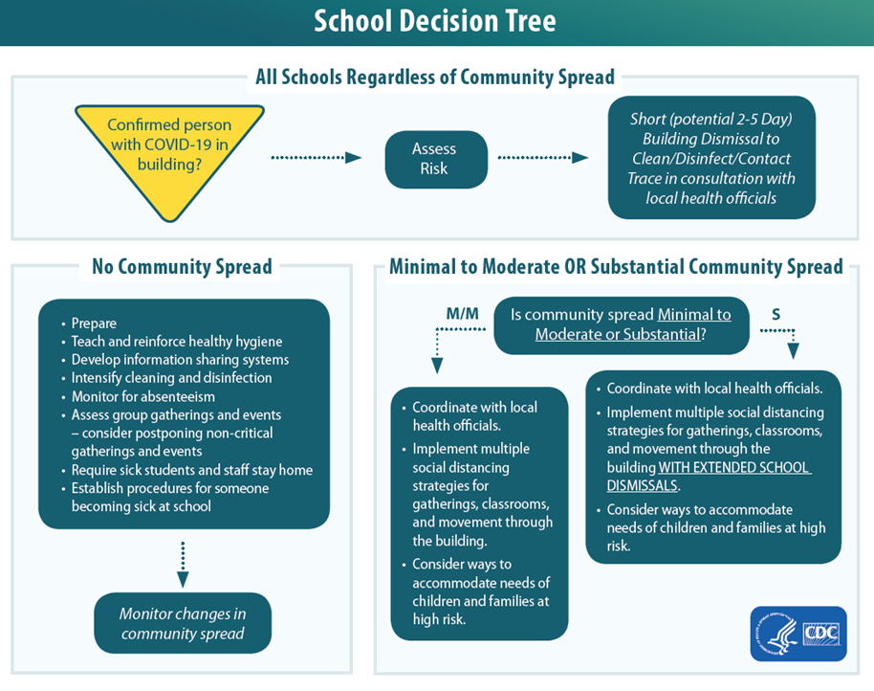

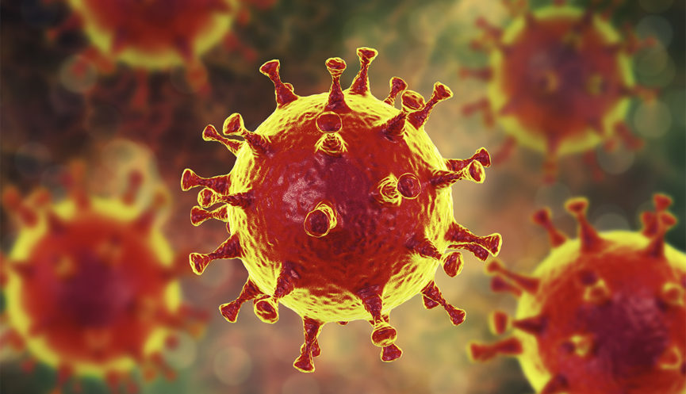

COVID-19: Hand-Washing Hints
- Clean your hands often.
- Wash your hands often with soap and water for at least 20 seconds. This is especially important after blowing your nose, coughing, or sneezing; going to the bathroom; and before eating or preparing food.
- Use hand sanitizer if soap and water are not available. Use an alcohol-based hand sanitizer with at least 60% alcohol, covering all surfaces of your hands and rubbing them together until they feel dry.
- Soap and water are the best option, especially if hands are visibly dirty. Avoid touching your eyes, nose, and mouth with unwashed hands.
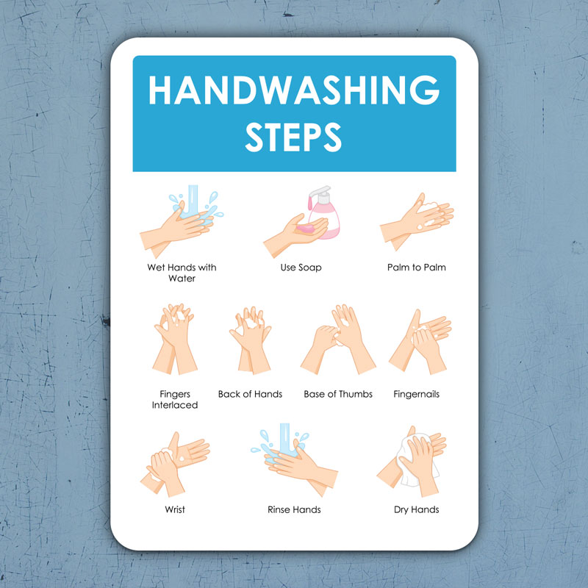

How COVID-19 spreads
The virus that causes COVID-19 is mainly spread by respiratory droplets. When someone infected with COVID-19 coughs or sneezes, respiratory droplets that contain the virus are expelled and can be breathed in by someone nearby. Although the virus cannot enter the body through the skin, the respiratory droplets carrying the virus can get into your airways or mucous membranes of your eyes, nose, or mouth to infect you. The virus can also be spread if you touch a surface contaminated with virus and then touch your eyes, nose or mouth, although this is not the primary way the virus spreads.

Guidance for cleaning and disinfecting
Routine cleaning and disinfecting is key to maintaining a safe environment for faculty, students, and staff.

- Cleaning removes dirt and most germs and is usually done with soap and water.
- Disinfecting kills most germs, depending on the type of chemical, and only when the chemical product is used as directed on the label.
- Clean and disinfect at least daily (or more, depending on use patterns) frequently touched surfaces and objects such as:

- Face shield
- Door knobs and handles
- Stair rails
- Classroom desks and chairs
- Lunchroom tables and chairs
- Countertops
- Handrails
- Light switches
- Handles on equipment (e.g., athletic equipment)
- Push-buttons on vending machines and elevators
- Shared toys
- Shared remote controls
- Shared telephones
- Shared desktops
- Shared computer keyboards and mice
- Bus seats and handrails
- Note: Computer keyboards are difficult to clean. Shared computers should have signs posted instructing proper hand hygiene before and after using them to minimize disease transmission. To facilitate cleaning, consider using covers that protect the keys but enable use of the keys.

How to clean and disinfect
Clean
- Wear disposable gloves to clean and disinfect.
- Clean surfaces using soap and water, then use disinfectant.
- Cleaning with soap and water reduces number of germs, dirt and impurities on the surface. Disinfecting kills germs on surfaces.
- Practice routine cleaning of frequently touched surfaces.
  - More frequent cleaning and disinfection may be required based on level of use.
  - Surfaces and objects in public places, such as shopping carts and point of sale keypads should be cleaned and disinfected before each use.
- High touch surfaces include:
  - Tables, doorknobs, light switches, countertops, handles, desks, phones, keyboards, toilets, faucets, sinks, etc.
Disinfect
- Recommend use of EPA-registered household disinfectant external icon.
Follow the instructions on the label to ensure safe and effective use of the product.
Many products recommend:
  - Keeping surface wet for a period of time (see product label).
  - Precautions such as wearing gloves and making sure you have good ventilation during use of the product.

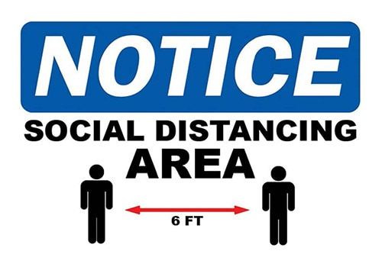

SOCIAL DISTANCING
Keeping a distance of six feet or more between people adds another layer of prevention against the spread of COVID-19 by minimizing the chance of coming into contact with the virus through respiratory droplets. Distancing of six feet or greater is key in preventing droplet spread when speaking loudly, singing, or playing a musical instrument, which have been connected to increased respiratory droplet spread.
School staff should try when possible to maintain 6-foot social distance among students, staff, and volunteers in all school environments, including classrooms, hallways, restrooms, cafeteria, playground, drop-off and pick-up locations, and school buses.
Where social distancing is difficult, face coverings are even more essential.
    - Distancing is to be reinforced with visual cues such as floor markings and signs.
    - Avoid using shared materials or shared spaces (lockers, cubbies, etc.)
    - Reduce the mixing of student groups.
    - Limit the number of visitors to the school building.
    - No parents or visitors will be allowed in the school building.
and consider eliminating field trips or large group events where intermingling often occurs.
    - Due to the nature of the school choir, drumlines, art classes, and other similar classes, 6-feet social distancing may not be adequate. Teachers and students should maintain at as much distance as possible when actively playing and performing or working in their art projects.
    - School officials, bus drivers and bus aides should endeavor to do the best they can to keep social distancing on buses.

When a confirmed case has entered the school,
regardless of community transmission

Following are the guidelines to be followed in the event that AEE might need to implement short-term closure procedures regardless of community spread if an infected person has been in the school building. If this happens, the following procedures regardless of the level of community spread are recommended to be followed:
- Coordinate with local health officials.
  - Once learning of a COVID-19 case in someone who has been in the school, immediately notify local health officials.
  - These officials will help administrators determine a course of action for their child care programs or schools.
- Dismiss students and most staff for 2-5 days.
  - This initial short-term dismissal allows time for the local health officials to gain a better understanding of the COVID-19 situation impacting the school.
  - This allows the local health officials to help the school determine appropriate next steps, including whether an extended dismissal duration is needed to stop or slow further spread of COVID-19.
- Local health officials’ recommendations for the scope (e.g., a single school, multiple schools, the full district) and duration of school dismissals will be made on a case-by-case basis using the most up-to-date information about COVID-19 and the specific cases in the community.
- During school dismissals, also cancel extracurricular group activities, school-based afterschool programs, and large events (e.g., assemblies, spirit nights, field trips, and sporting events).
- Discourage staff, students, and their families from gathering or socializing anywhere. This includes group child care arrangements, as well as gathering at places like a friend’s house, a favorite restaurant, or the local shopping mall.
- Communicate with staff, parents, and students.
- Coordinate with local health officials to communicate dismissal decisions and the possible COVID-19 exposure.
- This communication to the school community should align with the communication plan in the school’s emergency operations plan.
- Plan to include messages to counter potential stigma and discrimination.
- In such a circumstance, it is critical to maintain confidentiality of the student or staff member as required by the Americans with Disabilities Act and the Family Education Rights and Privacy Act.

Clean and disinfect thoroughly.
- Close off areas used by the individuals with COVID-19 and wait as long as practical before beginning cleaning and disinfection to minimize potential for exposure to respiratory droplets. Open outside doors and windows to increase air circulation in the area. If possible, wait up to 24 hours before beginning cleaning and disinfection.
- Cleaning staff should clean and disinfect all areas (e.g., offices, bathrooms, and common areas) used by the ill persons, focusing especially on frequently touched surfaces.
- If surfaces are dirty, they should be cleaned using a detergent or soap and water prior to disinfection.
- For disinfection most common EPA-registered household disinfectants should be effective. AEE will be using a fogging sanitizing system to disinfect school facilities and equipment on a periodic basis.
Make decisions about extending the school dismissal.
During school dismissals (after cleaning and disinfection), the school may stay open for staff members (unless ill) while students stay home. Keeping facilities open:
a) allows teachers to develop and deliver lessons and materials remotely, thus maintaining continuity of teaching and learning; and
b) allows other staff members to continue to provide services and help with additional response efforts. Decisions on which, if any, staff should be allowed in the school should be made in collaboration with local health officials.
- School administrators should work in close collaboration and coordination with local health officials to make dismissal and large event cancellation decisions.
- Administrators should seek guidance from local health officials to determine when students and staff should return to schools and what additional steps are needed for the school community. In addition, students and staff who are well but are taking care of or share a home with someone with a case of COVID-19 should follow instructions from local health officials to determine when to return to school.
Implement strategies to continue education and related supports for students.
- Ensure continuity of education.
  - Review continuity plans, including plans for the continuity of teaching and learning.
  - Implement flexible e-learning plans, including digital and distance learning options as feasible and appropriate.
- Ensure continuity of meal programs.
  - Consider ways to distribute food to students.
  - If there is community spread of COVID-19, design strategies to avoid distribution in settings where people might gather in a group or crowd. Consider options such as “grab-and-go” bagged lunches or meal delivery.

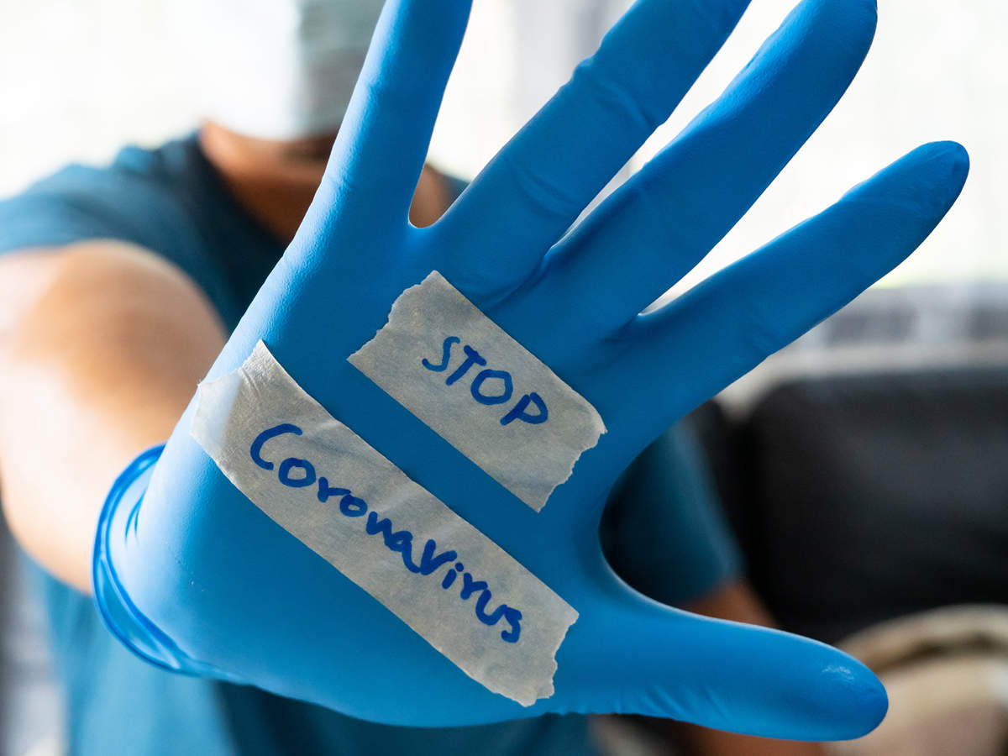

LUCAS COUNTY COMMUNITY TESTING
A collaboration between the Health Department, the Lucas County Commissioners, and Community and Corporate Partners has established COVID-19 testing sites for Lucas County residents. Available testing sites can be found below.
WHO SHOULD BE TESTED:
- Testing is most appropriate for community members experiencing symptoms of COVID-19 or with known exposure risk to a COVID-19 positive individual (What Your Test Result Means).

- The main symptoms of COVID-19 infection include a fever, cough, shortness of breath, and difficulty breathing. Visit the CDC’s COVID-19 Symptoms Page for additional reported symptoms, information on when to seek emergency medical attention, and to use the CDC Symptom Self Checker.

WHERE TO BE TESTED:
- RITE AID
- Place:
  - Drive-thru testing available at the 7225 Airport Highway location
- Time: Starting 6/4 testing hours will be 10-8 M-F and 10-5 on the Weekend.
- Appointment: Must have an appointment.
  - Pre-screening and appointments can be set up at www.riteaid.com
  - For Questions: (419) 866-8943
- Cost: Free

- WALMART ON CENTRAL
- Place: Drive-thru testing available at the Walmart Supercenter at 5821 Central Ave, Toledo OH
- Time: Testing is available M-W-F from 7 am – 9 am
- Appointment: Must have an appointment.
  - Pre-screening and appointments can be set up at www.MyQuestCOVIDTest.com
  - For Questions: (866) 697-8378
- Cost: Free

- CVS
  - Place: Drive-thru testing available at the CVS Pharmacy at 2104 S. Byrne Road, Toledo, OH
  - Time: Testing is available M-F from 9 am – 6 pm, on Sat 9 am – 5 pm, and on Sun 10 am – 5 pm
  - Appointment: Must have an appointment.
    - Pre-screening and appointments can be set up at www.CVS.com
    - For Questions: 419-389-9112
  - Cost: Free
- LABCORP
  - Place: Anti-body testing available at 1565 S. Byrne Rd Suite 105, Toledo OH
  - Time: Testing available Monday-Friday from 7:30 am – 4 pm
  - Appointment: Order Required, No Appointment Needed.
    - How Labcorp Works (419-381-1300)
    - Individuals without an order may have one created at Labcorp COVID-19 Antibody Testing
  - Cost: $10 if order is purchased from Labcorp website.
- Health Partners of Western Ohio
  - Place: Drive-thru and walk-up Drive-thru testing available at the Old West End Site (former Girl Scout Building) at 2244 Collingwood Blvd Toledo, OH
  - Time: Testing is available M-F from 8:15 am – 4 pm (All Ages)
  - Appointment: Must have an appointment.
    - Pre-screening and appointments can be set up by calling 567-318-3900
  - Cost: Free

- NHA: NEXUS HEALTHCARE CENTER
  - Place: Drive-thru and walk-up testing available at the Nexus Healthcare Center at 1415 Jefferson Ave
  - Time: Testing is available M-F from 9 am – 3 pm
  - Appointment: Must have an appointment.
    - Pre-screening and appointments can be set up by calling 419-214-5700
  - Cost: Free
- NHA: NAVARRE PARK FAMILY CARE CENTER
  - Place: Drive-thru and walk-up testing available at the Navarre Park Family Care Center at 1020 Varland Ave (Spanish Speakers Available)
  - Time: Testing is available M-F from 9 am – 3 pm
  - Appointment: Must have an appointment.
    - Pre-screening and appointments can be set up by calling 419-214-5700
  - Cost: Free
- TOLEDO FAMILY PHARMACY
  - Place: Drive-thru testing available at the 324 Main Street, Toledo
  - Time: Testing is available M/TR: 10am -1 pm, W/F: 1 pm-6 pm, Sat : 11 am-3 pm
Appointment: Must have an appointment
    - Visit DoINeedaCOVID19test.com or call 800-635-8611 to schedule an appointment
  - Cost: Free

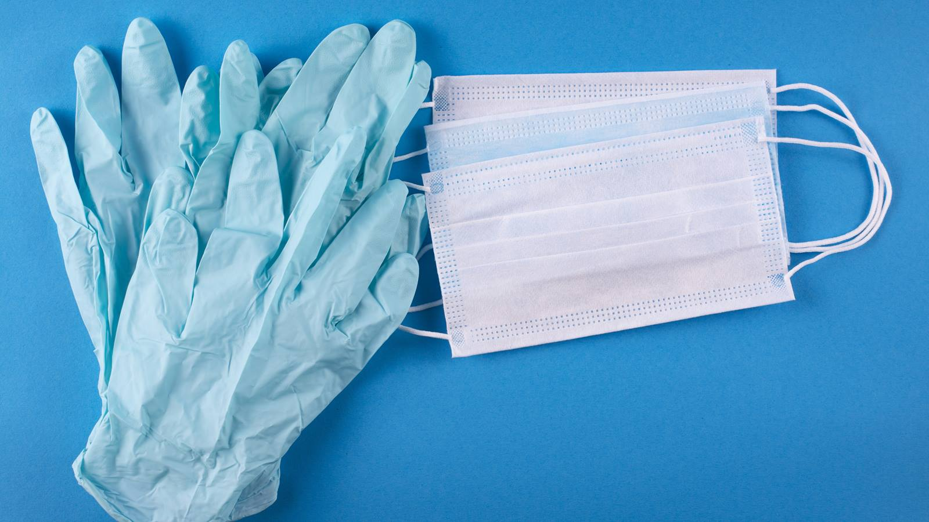

AEE CHECKLIST: INFECTION CONTROL MATERIALS

SCHOOL BUILDING

- Cloth Face Coverings
- Hand Sanitizer (with at least 60% alcohol)
- Cleaning Products (EPA registered disinfectants
- effective against coronavirus)
See EPA’s List N: Disinfectants for Use Against SARS-CoV-2
- Paper Towels / Tissues Students

TEACHERS AND INSTRUCTIONAL STAFF

- Cloth Face Coverings
- Hand Sanitizer (with at least 60% alcohol)
- Cleaning Products (EPA registered disinfectants effective against coronavirus)
See EPA’s List N: Disinfectants for Use Against SARS-CoV-2
- Paper Towels / Tissues

INDIVIDUAL SCHOOL STAFF DELEGATED TO PERFORM MEDICAL TASKS

- Cloth Face Coverings
- Surgical Masks
- Gowns
- Gloves
- Face Shields
- Screening Thermometers (temporal, touchless)
- Cleaning Products (EPA registered disinfectants
- effective against coronavirus)
See EPA’s List N: Disinfectants for Use Against
SARS-CoV-2

SCHOOL STAFF WHO MAY NEED TO MAKE HOME VISITS OR VISIT MULTIPLE SCHOOLS
(e.g., Social Workers, Physical Therapists, Speech Therapists, Instructional Coaches, School Psychologists, Behavioral Counselors)

- Cloth Face Coverings
- Hand Sanitizer (with at least 60% alcohol)

CUSTODIAL STAFF

- Cloth Face Coverings
- Hand Sanitizer (with at least 60% alcohol)
- Cleaning Products (EPA registered disinfectants effective against coronavirus)
See EPA’s List N: Disinfectants for
Use Against SARS-CoV-2
- Gloves

NUTRITION SERVICES STAFF

- Cloth Face Coverings
- Hand Sanitizer (with at least 60% alcohol)
- Cleaning Products (EPA registered disinfectants
effective against coronavirus)
- See EPA’s List N: Disinfectants for Use Against SARS-CoV-2
- Gloves

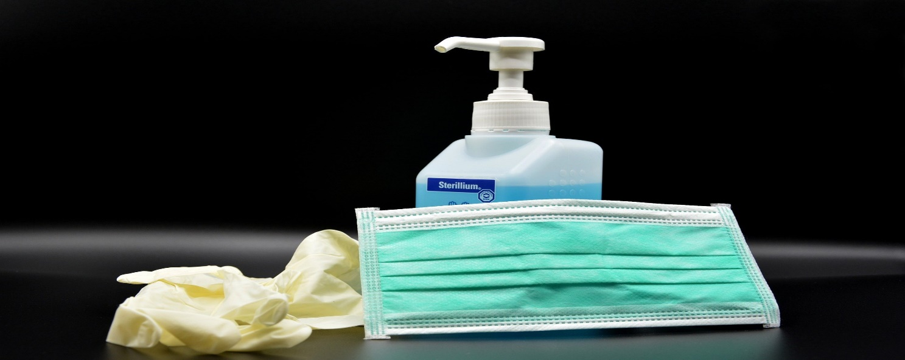

AEE CHECKLIST: INFECTION CONTROL MATERIALS cont.

ALL THER SCHOOL STAFF
(e.g., Administrators, Secretaries, Support Staff)

- Cloth Face Coverings
- Hand Sanitizer (with at least 60% alcohol)

BUS DRIVERS / BUS AIDES STAFF

- Cloth Face Coverings
- Hand Sanitizer (with at least 60% alcohol)
- Cleaning Products (EPA registered disinfectants
effective against coronavirus)
See EPA’s List N: Disinfectants for Use Against ARS-CoV-2
- Gloves
- Tissues / Paper Towels

PERSON WHO SCREENS POSITIVE FOR
COVID-19 SYMPTOMS ON-SITE

- Cloth Face Coverings OR Surgical Mask
- Hand Sanitizer (with at least 60% alcohol)
- Gloves

COVERING INDIVIDUAL ACCOMPANYING OR SUPERVISING A PERSON WHO SCREENS POSITIVE FOR COVID-19 SYMPTOMS ON-SITE

- Cloth Face Coverings OR Surgical Mask
- Hand Sanitizer (with at least 60% alcohol)
- Gloves

Although our understanding of COVID-19 continues to evolve, one thing that has remained constant is that using multiple layers of protection to protect against catching the virus is key.

