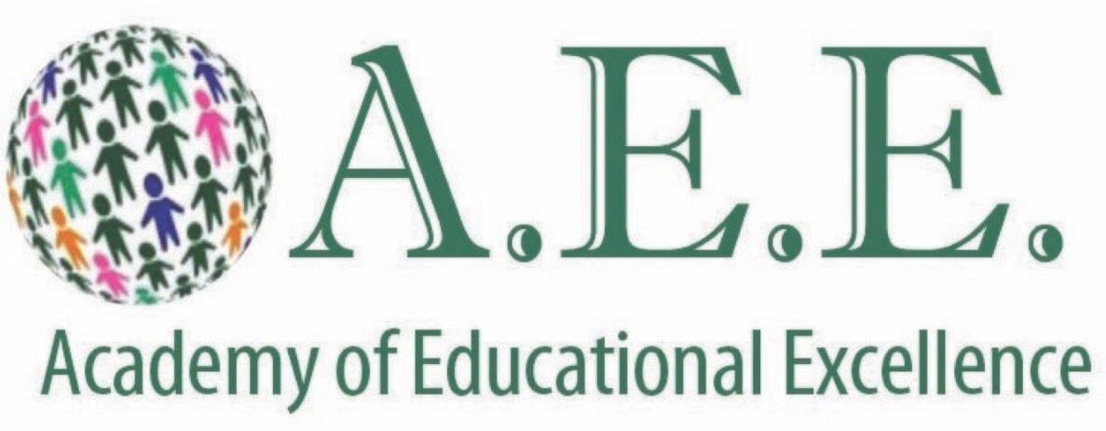
OFFICE OF THE DIRECTOR OF SPECIAL SERVICES
728 Parkside Boulevard, Toledo, Ohio 43607
Phone: 419-382-2280
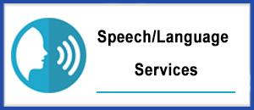
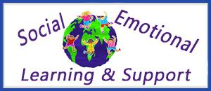

AEE: CHILD FIND SCHOOL POLICY

AS APPROVED BY THE GOVERNING AUTHORITY ON AUGUST 15, 2020

The Individuals with Disabilities Education Act includes the Child Find mandate. Child Find requires all school districts to identify, locate and evaluate all children with disabilities, regardless of the severity of their disabilities. This obligation to identify all children who may need special education services exists even if the school is not providing special education services to the child. Each school district shall adopt and implement written policies and procedures approved by the Ohio department of education, office for exceptional children, that ensure all children with disabilities residing within the district, including children with disabilities who are homeless children or are wards of the state, and children with disabilities attending nonpublic schools, regardless of the severity of their disability, and who are in need of special education and related services are identified, located, and evaluated as required by the Individuals with Disabilities Education Act, as amended by the Individuals with Disabilities Education Improvement Act of 2004, December 2004 (IDEA) and federal regulations at 34 C.F.R. Part 300 (October 13, 2006) pertaining to child find, including the regulations at 34 C.F.R. 300.111 and 300.646 (October 13, 2006) and as required by the provisions of this rule.

CHILD FIND
Child Find is the process of locating, evaluating, and identifying children with disabilities who may be in need of special education and related services.
What is a disability?
- For children ages birth to 3 – A physical or mental condition that may result in a developmental delay.

- For children ages 3 through 5 – A documented deficit in one or more of the following developmental areas: communication, vision, hearing, motor skills, social emotional/behavioral functioning, self-help skills, and/or cognitive skills.

- For children ages 5 through 21 – Identification of one or more of the following conditions: autism, deaf-blindness, hearing impairment including deafness, mental retardation, multiple disabilities, orthopedic impairment, other health impairment, emotional disturbance, specific learning disability, speech or language impairment, traumatic brain injury, and/or visual impairment including blindness.

What is the purpose of Child Find?
- To alert parents, professionals, and the public to children who may have special needs
- To guarantee that school districts find children who may have disabilities and who otherwise may not have come to their attention
- To enable eligible children to receive the special education and related services that are needed
- To promote public awareness of disabilities

Why is Child Find Necessary?
The primary purpose of the Individuals with Disabilities Education Act is to ensure that all children with disabilities receive a free appropriate public education, including special education and related services that are "designed to meet their unique needs and prepare them for further education, employment and independent living …" (20 U.S.C. 1400(d); Wrightslaw: Special Education Law, pages 48, 207)
Another purpose of the law is to help each State implement a statewide, comprehensive, coordinated multi-disciplinary system of Early Intervention Services for infants and toddlers with disabilities. Young children with disabilities must receive appropriate early intervention services to "prepare them for further education, employment, and independent living."
Congress encourages states to provide Early Intervention Services so children with developmental delays and other disabilities will receive treatment early. Congress enacted the Early Intervention Program for Infants and Toddlers to provide interagency coordination of services to children from birth to two years of age. Under IDEA, states must ensure that children with disabilities are eligible for special education services by age three.
How is Child Find Implemented?
The Child Find mandate requires each state to devise a practical method to determine which children are receiving the needed special education services, and which children are not. After identifying children who may need services, all necessary evaluations must be completed on these children, at no cost to parents.
The Individuals with Disabilities Education Act mandates "general public notice obligations", i.e., using notices to inform and educate the public about the need to locate and identify all children with disabilities.

GENERAL GUIDELINES:
(1) The Child Find policy and procedures that AEE adopts and implements under this rule shall ensure that:
(a) All children with disabilities residing in the state, including children with disabilities who are homeless children or are wards of the state, and children with disabilities attending nonpublic schools, regardless of the severity of their disability, and who are in need of special education and related services, are identified, located, and evaluated; and
(b) A practical method is developed and implemented to determine which children are currently receiving needed special education and related services.
(2) Use of the term developmental delay:
The following provisions apply with respect to implementing the child find requirements of this rule:
(a) The Ohio department of education has adopted in rule 3301-51-11 of the Administrative Code a definition of "developmental delay" under 34 C.F.R. 300.8(b) (October 13, 2006) and under that section has determined in rule 3301-51-01 of the Administrative Code that the term applies to children aged three through five years;
(b) A school district is not required to adopt and use the term developmental delay for any children within its jurisdiction;
(c) If a school district uses the term developmental delay for children described in rule 3301-51-01 of the Administrative Code as experiencing developmental delays, the school district must conform to both the state's definition of that term in rule 3301-51-11 of the Administrative Code and to the age range of three through five years of age which is the age range subset that has been adopted by the Ohio department of education in rule 3301-51-01 of the Administrative Code.
(3) Other children in Child Find
Child Find must also include:
(a) Children who are suspected of being a child with a disability under the definition of child with a disability in paragraph (B)(10) of rule 3301-51-01 of the Administrative Code and in need of special education, even though they are advancing from grade to grade; and
(b) Highly mobile children, including migrant children.
(c) The identification of children as children with disabilities, including the identification of children as children with disabilities in accordance with a particular impairment described in the definition of "child with a disability" in paragraph (B)(10) of rule 3301-51-01 of the Administrative Code;
(d) The placement in particular educational settings of these children; and
(e) The incidence, duration, and type of disciplinary actions, including suspensions and expulsions.

What methods should be used to identify and locate children who may need special education services?
In order to identify and locate children who may need special education services the school will use plans that may include: door-to-door surveys, brochure mailings to school parents, public education programs and other public meetings, physician referrals, contacts with day care providers, and surveys of private school personnel. (The Office for Civil Rights (OCR) of the Education Department has accepted these plans as a way to identify and locate children with special needs).

