FAMILY MATTERS EVERY CHILD. EVERY PARENT.

ACADEMY OF EDUCATIONAL EXCELLENCE 728 Parkside Boulevard, Toledo, Ohio 43607

A monthly newsletter from the Department of Special Services

VOL. 1 Issue 4 WORKING TOGETHER FOR FAMILY SUCCESS OCTOBER, 2020
Family Matters is an outreach effort from the Academy of Educational Excellence– Department of Special Services and its SPED Program. Family Matters will provide parents with information about special education and other resources available to assist them to help their children.

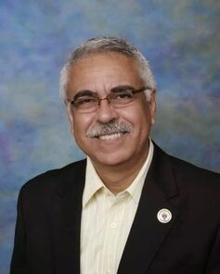 | MESSAGE FROM THE DIRECTOR OF SPECIAL SERVICES  Dr. Israel I. Koppisch  iikoppisch@aeetoledo.org  Tel: 419-382-2280
Dear Parents:

Why don’t adults always do exactly what we feel like doing, when we feel like doing it? This is a question that you might hear from kids, and it perfectly encapsulates what baffles them about adults.

As adults, we pretty much have free rein to do whatever we want, whenever we want. The vast majority of us won’t get arrested for not showing up to work, and no one will haul us off to prison for eating cake for breakfast. So, why do we show up for work? Why don’t we eat cake for breakfast? Perhaps the better question is, how do we keep ourselves from shirking work when we don’t want to go? How do we refrain from eating cake for breakfast and eating healthy, less-delicious food instead?

The answer is self-regulation. It’s a vital skill, but it’s also something we generally do without much thought. We encourage you to keep reading if you want to learn more about what self-regulation is, how we make the decisions we make, and why we are more susceptible to temptation at certain moments, read on. THIS ALSO APPLIES TO OUR CHILDREN.

What is Self-Regulated Learning?
Self-regulated learning (SRL) refers to the process a student engages in when he/she takes responsibility for their own learning and applies it to their academic success (Zimmerman, 2002). This process happens in three steps:
- Planning: The student plans her task, sets goals, outlines strategies to tackle the task, and/or creates a schedule for the task;
- Monitoring: In this stage, the student puts his/her plans into action and closely monitors their performance and experience with the methods chosen;
- Reflection: Finally, after the task is completed and the results are in, the student reflects on how well they did and why they performed the way they did (Zimmerman, 2002).

When students take initiative and regulate their own learning, they gain deeper insights into how they learn, what works best for them, and, ultimately, they perform at a higher level. This improvement springs from the many opportunities to learn during each phase:
- In the planning phase: students have an opportunity to work on their self-assessment and learn how to pick the best strategies for success;
- In the monitoring phase: students get experience implementing the strategies they chose and making real-time adjustments to their plans as needed;
- In the reflection phase: students synthesize everything they learned and reflect on their experience, learning what works for them and what should be altered or replaced with a new strategy.

If you’re thinking that self-regulation and self-control have an awful lot in common, you’re correct. They are similar concepts and they deal with some of the same processes. However, they are two distinct constructs. As psychologist Stuart Shanker (2016) put it: “Self-control is about inhibiting strong impulses; self-regulation is about reducing the frequency and intensity of strong impulses by managing stress-load and recovery. In fact, self-regulation is what makes self-control possible, or, in many cases, unnecessary.”
This monthly edition of our FAMILY MATTERS NEWSLETTER is focused in trying to help parents with strategies on how to address your children’s behavior in a positive manner. We hope you enjoy reading this month newsletter.
Cordially,
Dr. Israel I. Koppisch

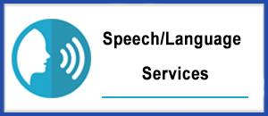
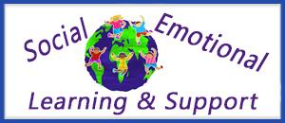
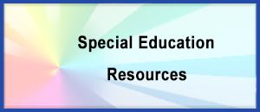

MESSAGE
FROM THE INTERVENTION SPECIALIST
Margaret Hallett
mhallett@aeetoledo.org

Greetings Families!

This month we are talking about social emotional health. Dr. Koppisch shared the importance of self-regulated learning, which is a part of the Ohio K-12 Social Emotional Learning Standards. The state of Ohio provides teachers with standards that we are held accountable to teach your children. In June of 2019, they adopted the Social Emotional Learning Standards. There are 5 areas that we are to be teaching your child: self-awareness, self-management, social-awareness, relationship skills, and responsible decision making. According to the State of Ohio, “Research demonstrates that students who receive support for social and emotional learning in schools do better academically, socially and behaviorally. Social-emotional learning also has been shown to positively impact economic mobility and mental health outcomes. Developing these skills in our students is an important part of meeting the needs of the whole child.”

You may be wondering how do we teach this at The Academy of Educational Excellence? I’m glad you asked! We use a curriculum called The Leader-In-Me. This curriculum is based on a book that many CEOs have read to help them achieve their financial and personal greatness. The 7 Habits of Highly Effective People was written by Steven Covey. The 7 habits are:

- Be Proactive – You take initiative, help others, make good choices, be responsible, and stay organized
- Begin with the End in Mind- Know where you want to go, make a plan, set clear expectations, set goals, consider consequences, think ahead
- Put First Things First- Work then play, stay focused on the goal, say “no” to time wasters, prioritize what is the most important

The first 3 habits are about leading yourself. You can’t lead other people nor companies if you are not able to lead yourself. These habits teach our students to be self-aware of how they are going to deal with other people’s reactions, how they want to improve their life, what is most important to them. They help students with self-management. Students must think about how to positively react to others and how others will react to what they say and do. We teach them to prioritize what is most important which helps them effectively make responsible decisions.

- Think Win/Win- We teach students to respect others, be a friend even when their friend is not there, give compliments, keep promises, solve social problems between yourselves, find ways problem solve so everyone can win in a given situation.
- Seek First to Understand Then to Be Understood- Listen carefully to what people are REALLY saying by listening with your eyes, ears, and heart. Use the word “I” not “you” when you clarify what others are saying. Ex: I hear you saying that you want to play ball with me, but I see you watching the other kids coloring with chalk. Do you want to play with the ball or chalk? Sometimes we can hear with our heart. This means that we can feel how others are feeling about something by their actions. Let’s say that I went to a movie theater and another couple gets there at the same time. I see a man get out of his car quickly to open the door for his date. My heart will hear that he really respects and cares for her. Or, I’m at the park and I see a bunch of children playing on the playground and their parents are standing around playing on their phones. There’s one mom who is playing tag with her children and they are running away from her laughing and smiling. Mom is laughing too. My heart is happy because my heart can hear/feel much she loves them.
- Synergize- work as a team, be humble, listen to others’ ideas, celebrate others’ strengths
- Sharpen the Saw- Eat healthy, get enough sleep, balance work with rest time, take care of the soul, mind, and body

The second set of habits are about leading others through developing a strong relationship with social awareness and relationship skills. Here at Academy of Educational Excellence we are not only teaching your children academic success we are also looking at the whole child.

Sincerely,
Mrs. Margaret Hallett

The Most Important Life Skill to Teach Children: Self-Regulation

To succeed in school, students need to be able to focus, control their emotions, and adjust to change. Many students with learning issues, ADHD, or even adverse childhood experiences and trauma that affect their executive functioning and ability to self-regulate, do not have the tools they need to focus and pay attention, keep their emotions in check, adjust to change, or handle the frustration that is sometimes a part of interacting with others or learning something new. This can make it very challenging to complete required learning tasks. At AEE, we are determined that in order to make learning accessible to these students, we have to first work on developing their self-regulation skills.

Today it is easy to spot frustrated children. They often show their feelings in behavior we can see (e.g., tantrums and meltdowns). When this behavior happens occasionally, we can usually manage. But, what happens when challenging behavior becomes more frequent, more intense, and longer lasting than the average outburst? We may feel frustrated, dismayed, helpless, and even hopeless at times. How can we make sense of what is going on with children? And, what can we do to help?

What is self-regulation and why is it important?
It is tempting to label challenging behavior as oppositional, defiant, manipulative, and attention seeking. But, challenging behavior is often not in children’s control. It is more accurate and helpful to understand this behavior as a sign that children cannot handle their big emotions (e.g., mad, sad, sacred). When they feel overwhelmed, their emotions are getting the best of them. That is, they cannot self-regulate. Self-regulation is the ability to remain calm, cope with big emotions, adapt, and respond appropriately to our environment. Self-regulation is important because it allows children to do well in school, with friends, and at home. It helps children feel good about what they can handle and it helps children feel good about themselves.

Self-regulation and brain development

It can be helpful to think of the brain as made up of two different but equally important parts: the downstairs brain and the upstairs brain. The downstairs brain controls our body’s basic functions (e.g., heart rate and breathing) and stress response (e.g., fight, flight, freeze). When our downstairs brain senses danger, it moves us to act before we think. This survival instinct to panic and react with adrenaline pumping through our bodies can be life-saving. The problem arises when our downstairs brain wrongly interprets everyday stress as a danger. When children do not have the skills to meet the demands of their environment, their strong emotions can trigger them to react without thinking. If ongoing, this can lead to a combination of social, emotional, behavioral, and academic challenges.

When children feel safe and relaxed, they can use their upstairs brain. This part of the brain gives rise to self-awareness and self-control. It allows us to pause in the moment and think before we act. During this moment, we can reflect, consider other perspectives, empathize with others, plan, reason, make good decisions and problem-solve. The development of our upstairs brain determines how able we are to self-regulate. The upstairs brain takes time to develop fully, growing all the way into young adulthood. This means that younger children have more difficulty than older children with self-regulation (coping and adapting). Their environment easily triggers very young children. When they feel big emotions (e.g., mad, sad, scared) they throw a tantrum or have a meltdown. They find it difficult to cope with and adapt to change. Frequent or intense challenging behavior is often a sign that children do not have the skills they need to calm themselves (regulate) when they feel overwhelmed.

As children grow up and their brains develop, they become abler to manage their thoughts, feelings, and behaviors. They become better at:

- staying calm when they feel upset
- stopping to think before they act
- cooperating with others
- doing what is expected of them, even when they don’t want to
- paying attention and avoiding distraction
- staying focused on their goals
- waiting to get what they want
- adapting to changes in their environment

ACADEMY OF EDUCATIONAL EXCELLENCE
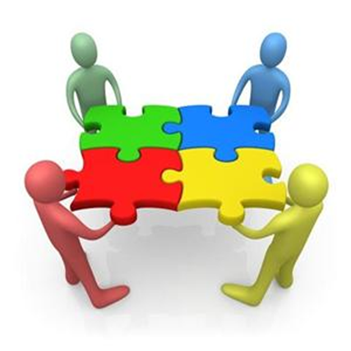
Department of Special Services - SPED Programs and Support Staff

Dr. Israel I. Koppisch
Director, Department of Special Services
Margaret Hallett, Intervention Specialist

Heather Dinklage, School Psychologist
Lauren Notestine, Speech and Language Therapist
Alysia Kusner, Occupational Therapist
Roye Durden, Licensed Social Worker / Behavior Specialist

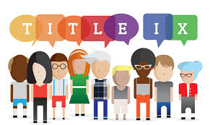

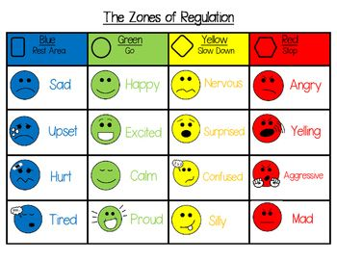

How can parents support the development of self-regulation in their children?

Self-regulation involves a set of skills that allow us to manage our big emotions and think before we act.
Here are some pointers for how you can support the development of regulation skills in your children.

- Manage your own stress. Get your own needs met so that you can support children and be a positive role model.

- Keep the end goal in mind. The end goal is not to simply decrease children’s challenging behavior. We want to teach skills. When children learn how to cope with stress, their behavior will improve. You will notice that they can handle changes in their environment better and respond to stress more calmly.

- Stay calm and model self-regulation. Remember that when children are reacting in the moment, they are in survival mode. Their downstairs brains are in full swing. Do not try to talk to them because they cannot respond to logic or reason. Instead, stay calm, show empathy, help them become self-aware, and guide them through sensory experiences and calming strategies.

- Be supportive and encouraging. Help children feel cared about, valued, and understood as they learn to regulate. Show genuine interest and engage with them as a coach and mentor.

- Ensure that children’s resource pool for regulation is regularly replenished. Sleep, a balanced diet, and regular exercise are essential. Help children plan for activities they enjoy and in which they do well.

- Reduce unnecessary demands. Review children’s routines to make sure they are not overloaded. Too many responsibilities will increase stress and decrease children’s energy levels to regulate.

- Provide structure and consistency. Let children know what to expect and what is expected of them (e.g., routines, clear rules, proactive planning). Predictability helps to decrease stress.

- Collaborate and make learning about regulation fun. Be creative when helping children develop, practice, and adapt coping strategies toward regulation. Listen to their ideas. Talk about ‘learning to regulate’ in ways they can understand. For example, if children like science, present this task to them as an experiment. If they like spy games, present it as a mission.

- Expand their vocabulary. Talk to children about their feelings. Teach them about their resource pool.

- Enhance their self-awareness to help them self-monitor. Help children rate their emotions and energy reserve on a scale from 1 (low) to 5 (high). Help them identify strategies to calm and ways to refill their resource pool.

- Help them develop a toolbox of coping strategies to use when dysregulated. The idea is to help children stop in the moment - stay calm and think - and not act on their big emotions.

  - Mental break (e.g., book, music, coloring, creativity, hobbies, games, movies)
  - Physical break (e.g., dance, sports, walk, stretch)
  - Spiritual break (e.g., yoga, meditation, mantra)
  - Sensory experience (e.g., sound, taste, touch, movement)
  - Grounding activity (e.g., deep breathing, slow counting, visual imagery)
  - Positive self-talk (e.g., affirmations)
  - Social support (e.g., ask for help, connect with a friend/ parent)

Self-regulation is a skill that needs to be supported in children because it is key to their overall success and happiness. Children who can cope with stress, anger, disappointment, and frustration are abler to do well in school, with friends, and at home. Remember that the more children practice regulating themselves, the easier it will become for them to cope with and adapt to change. You can help children by removing unnecessary demands and guiding them with loving support.

