FAMILY MATTERS

ACADEMY OF EDUCATIONAL EXCELLENCE 728 Parkside Boulevard, Toledo, Ohio 43607

A monthly newsletter from the Department of Special Services

VOL. 1 Issue 2 WORKING TOGETHER FOR FAMILY SUCCESS AUGUST, 2020
Family Matters is an outreach effort from the Academy of Educational Excellence– Department of Special Services and its Special Education Program. Family Matters will provide parents with information about special education and other resources available to assist them to help their children.
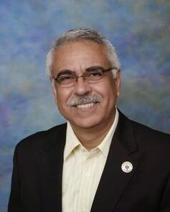  MESSAGE FROM THE DIRECTOR OF SPECIAL SERVICES Dr. Israel I. Koppisch | MESSAGE FROM THE INTERVENTION SPECIALIST  Margaret Hallett
Dear Parents:  School success begins at home! While your child is learning ABCs, 123s, and much more, he/she can get the year off to a great start with these other ABC’s:  Attend every day or participate on online learning everyday  More time in class = more learning. Help your youngster attend school or online learning program REGULARLY. Schedule doctor appointments outside of school hours.  Be organized  Forgotten homework? Unacceptable!! Good organizational skills prevent those problems. Use a special folder for bringing home and returning homework and use a zipper bag to store pencils and other supplies.  Check in daily  Designate a time each day to sit down with your youngster, talk about what he/she did at school, and review papers he/she brought home. You might read a story they might have written or look over their math work. This simple routine shows your child your interest in their performance and their learning process.  To improve your child’s attention span/ memory; ability to discriminate between/among letter, numerals or sounds and/or writing ability; improve their eye-hand coordination, amongst others, they need a structured and consistent environment both at home and school. Parents can help support all what school staff is doing to help your child improve their needs. Attending school consistently will help them improve and achieve the goals planned for them for this school year.  Cordially,  Dr. Israel I. Koppisch  iikoppisch@aeetoledo.org  Tel: 419-382-2280  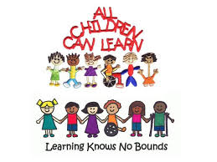 | Greetings Families! I hope you are all enjoying your summer! In August we start to think about the school year and how can be best help our children to be successful next year.  Have you heard of the phrase “summer brain drain”? This is a very real problem and many researchers have conducted many different researches on how to prevent it. Having your child read for at least 20 minutes per day has proven to help stop the loss of learning. I wonder if you have the same struggles I have on getting my children to read when they would rather be playing outside or gaming on their electronics.  To combat this, one summer I established an electronic black out time within the day. It turned into a nap time; they would read a book get bored and fall asleep. The next summer I found the thing that works best for us. I read books that were too advanced for my youngest and at grade level for my oldest. I felt funny about reading aloud to my oldest that was in going into his freshman year as if he was a little boy. I was shocked that he enjoyed being read to. Then again, I enjoy listening to an audio book when traveling in the car. I guess there is no age limit for reading out loud to someone; we all love a good story.  I just read some recent research that shows that listening to someone read improves the person’s vocabulary, reading comprehension and motivation. When we take the decoding burden off of reading we grant our children with greater access to complex words that they need to know. Just listening to a book is a valid instructional technique engaging deep limbic parts of the brain which are responsible for storing memories and word knowledge.  As parents, you are your child’s first and most important teacher. Please give your son, daughter, grandchild the gift of reading. If getting them to read for pleasure on their own is like pull teeth, like my boys, then read to them! It will become a welcomed part of your day with your children. My boys always giggled when I would read something silly and add in my personal two cents on the subject. This encourages them to do the same. These side conversations engaged them into the book and indirectly taught them comprehension tools (person-to-text, text-to-text, and world-to-text). We talked about how we can relate to a character, person-to-text connection. We talked about how the author started up the book the same way another author started up a book, text-to- text connection. Then sometimes you might read a book and you see how there is a connection to how a character is feeling about their world and something very similar is going on in our world too, world-to-text connection.  We have a few weeks before school starts. Please check out these sites where you can find free ebooks and audio books for the children in your life.  www.toledolibrary.org has audio books and electronic books you can listen to or read  www.getepic.com parents can receive a 30 day free trial  www.readworks.org is completely free for families  www.starfall.com for younger K-2 students  www.storiesonline.net this one has activity guides that go along with the book. This site it great for K-2 for the picture books and activities that go along with the stories  www.oxfordowl.co.uk I recommend this site for the older 3rd-6th graders. This is a free sight with a bunch of information for both reading and math. Click on your child’s age and see what you can find that is age appropriate for them. Make sure you click on ebooks if you click on books it will take you to amazon to buy it. The ebooks are free with a free account. They have chapter books that are age appropriate up to 6th grade.  Sincerely,  Mrs. Margaret Hallett mhallett@aeetoledo.org
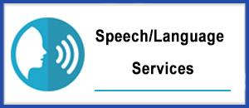
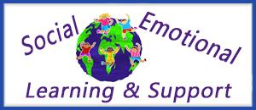

ABC’s OF STUDENT SUCCESS: “P” IS FOR PARENT INVOLVEMENT
Research shows that students with parents who are involved in their education have higher achievement. You can get involved in your child’s education by…
- Reading with your child every night. Regular reading improves many skills. It reinforces that reading is a valuable and pleasurable activity.
- Volunteering at school. Call your child’s teacher about how you can help at school or from home.
- Attending school activities. Be your child’s number ONE fan!!!!

Achieving Equity in Special Education

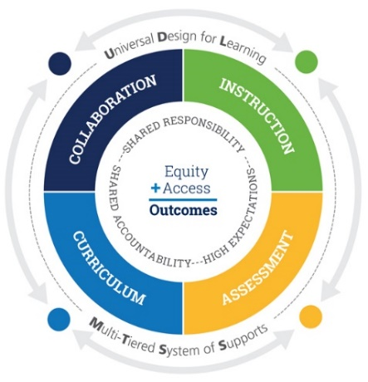
The issue and importance of equality has been a common fixture in the American vernacular for the past sixty plus years. As a whole, working towards equality for all people, regardless of unalterable characteristics, is a valid and worthy pursuit. For special education, however, equality falls short of what is needed and desired for children with disabilities – both legally and morally. As a community of people passionate about serving these children, we need to move from a paradigm focused on equality and one that works toward equity.
Why equity? Why now?

People often confuse the two terms as synonyms, when in fact they are both quite different things with very different intended outcomes. Both equality and equity aim to ensure basic fairness. With equality, the end goal is simple fairness – everyone has the same starting point and is treated exactly the same. With equity, however, the presumption is that not all people begin from the same place – so each person is given what they need to be successful, based on their unique abilities and needs.

At the Academy of Educational Excellence- SPED PROGRAM, we are committed in providing our special needs students a MULTI-TIERED SYSTEM OF SUPPORTS that will support the learning design stated for them in their IEP’s, supported by a team of professionals collaborating to provide the instruction needed based on a modern curriculum and periodically administered assessments to base our decisions on, according to the child’s growth, strengths and weaknesses.

Bringing Back the ‘I’ in Individualized Education Programs
The INDIVIDUALIZED EDUCATIONAL PLAN (IEP) indicates the recommended program and services, including related services that will be provided for the student to:
- advance appropriately toward his or her annual goals;
- be involved and progress in the general education curriculum
- participate in extracurricular and other nonacademic activities; and
- be educated and participate in activities with other students with disabilities and nondisabled students.
The regulations require that the IEP must indicate:
- the projected date for initiation of the recommended special education program and services;
- the recommended special education programs and related services;
- the anticipated frequency, duration and location for each of the recommended programs and services, including the supplementary aids and services and program modifications to be provided to or on behalf of the student;
- whether the student is eligible for a 12-month special service and/or program and the identity of the provider of services during the months of July and August;
- the class size, if appropriate;
- a statement of supports for school personnel on behalf of the student; the general education classes in which the student will receive consultant teacher services;
- any assistive technology devices or services needed for the student to benefit from education, including the use of such devices in the student’s home or in other settings;
- a statement of any individual testing accommodations to be used consistently by the student in the recommended educational program and in the administration of district-wide / state-wide assessments of student achievement and, in accordance with Department policy, in State assessments of student achievement that are necessary to measure the academic achievement and functional performance of the student.

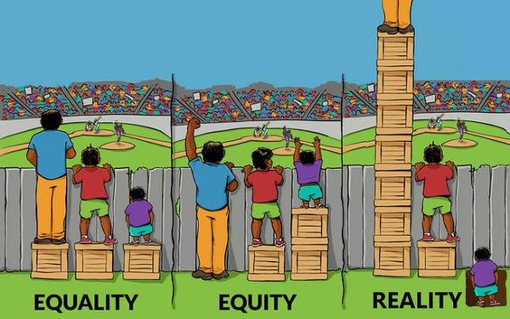

“Data from around the world show that children’s chances of getting a quality education are lower if they come from poor families; if they live in remote rural areas; if they are girls; if they have a disability; if they belong to an ethnic or racial group that faces discrimination in their society; or if they live in an area affected by crisis. Where these factors overlap they often reinforce deprivations.” UNICEF, 2016

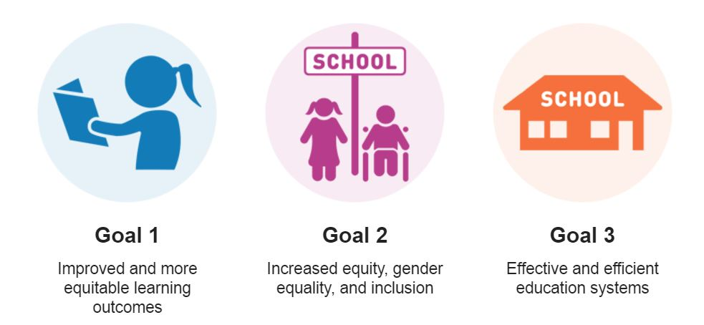

Every child deserves a chance to survive, a chance to learn, a chance to dream.
AT THE ACADEMY OF EDUCATIONAL EXCELLENCE
WE ARE COMMITTED IN PROVIDING ALL OUR STUDENTS
WITH QUALITY EDUCATION SUITED TO THEIR NEEDS.

Department of Specials Services - SPED Programs and Support Staff
Dr. Israel I. Koppisch
Director, Department of Special Services
Margaret Hallett, Intervention Specialist
Hannah Jeffers, Paraprofessional
Perris Loggins, Paraprofessional
Cynthia Kennedy, School Psychologist
Lauren Notestine, Speech and Language Therapist
Alysia Kusner, Occupational Therapist
Roye Durden, Licensed Social Worker / Behavior Specialist

