***HOME OF THE MIGHTY PENGUINS***  ****[](http://paw-patrol.wikia.com/wiki/The_Penguins)****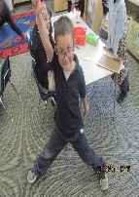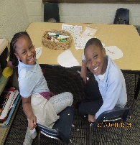

Sponsor: North Central Ohio Education Service Center

**2019-2020 School Profile**

***AN ELEMENTARY LEADERSHIP SCHOOL***

***IRN-- 013195***

**Academy of Educational Excellence**

**MISSION**

*The mission of the Academy of Educational Excellence is to develop the whole child, allowing them to achieve their full academic potential, while preparing them for global leadership. This will be accomplished through rigorous mastery-focused curriculum including foreign languages, technology, enthusiastic teaching staff, and a caring involved community.*

**STUDENTS K--6**

Enrollment 109

Economically Disadvantaged 98.8%

Attendance rate: 85.8%

Black, Non-Hispanic 88.4%

Students with Disabilities 17.6%

**TEAM OF EXCELLENCE**

**Ann Harris**

*Superintendent*

**Dr. Israel I. Koppisch**

*School Leader*

**Anita Bass**

*Registrar / EMIS Coordinator*

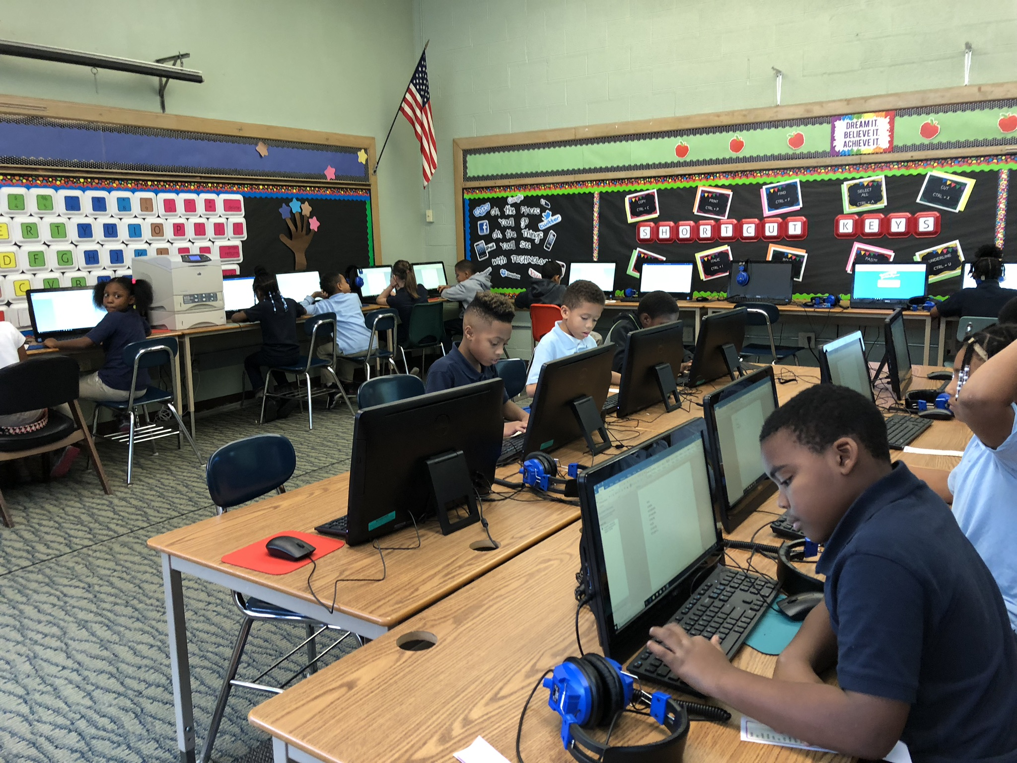

**ACADEMIC PERFORMANCE**

**Ohio Achievement Assessments**

**Third Grade Reading Guarantee requirements for promotion to the 4th grade— 100.0% Reading Proficient-- NR**

**Reading / Mathematics 4th -5th -6th grade- Science-5th grade--0020NR**

**FUNDING**

**Annual Income**

**$1,425,397.94**

**State Funds: $1,190,481.21 83.5%**

**Federal Funds: $234,916.73 16.5%**

**TOTAL EXPENDITURES: $1,386.694.21**

**Operating Spending per pupil: $8,265.**

**77.9% of funds spent on classroom instruction**

**Funds spent on non-classroom instruction: $6,438. (per pupil)**

**Non-Classroom Spending: $1,827. (per pupil)**

**Federal Funds: $1,614. (per pupil)**

**State and Local Funds: $6,651. (per pupil)**

**Provided by ODE 2019-2020**

**2015-2016 Fiscal Audit—No findings**

**2016-2017 Fiscal Audit—No findings**

**2017-2018 Fiscal Audit—No findings**

**2018-2019 Fiscal Audit—No findings**

**2019 AUDITORS AWARD**

**STUDENTS ENROLLED BY GRADES**

Kindergarten 24 21*

First Grade 19 12*

Second Grade 20 17*

Third Grade 18 14*

Fourth Grade 20 15*

Fifth Grade 15 12*

Sixth Grade 22 17*

TOTAL 138

*Ended school year with 108*

**CURRICULUM HIGHLIGHTS**

* Reading: Success for All / Journeys / A to Z / RAZ Kids
* Math: EUREKA Math / MobyMax/ KHAN Academy
* Social Studies: McMillan Series
* Science: McMillan Series
* Additional offerings: Technology / Typing.com, The Leader in Me, Visual Arts, Music,Drumlines and Stepsides
* Positive Behavior Intervention Program
* Behavior Counseling

**ETHNIC SCHOOL COMPOSITION**

White 7 5 %

Black 120 86.96%

Multiracial 9 6 %

Hispanic 2 1.45 %

**ODE REPORT CARD**

**Indicators Met: NR\***

**Performance Index: NR\***

**Value-added Overall: NR\***

**Students not state tested due to the COVID-19 pandemic**

**Poverty Status: 94%**

**Attendance Rate: 94.8%**

**Male Attendance Rate: 95.4%**

**Female Attendance Rate: 94.0%**

**AEE--Compliant with the federal requirement for implementing a local wellness policy.**

**GOVERNING BOARD**

**Charles Harrison** (4 yrs)

*President*

Allison Cox (9 yrs)

Beverly Tucker (5 yrs)

John Walthall (1 yr)

Lena Webb (2 yrs)

Todd Johnson - Treasurer

**TEACHER / STAFF**

1 District Superintendent

1 School Leaders

1 Registrar / EMIS Coordinator

1 Dean of Students

2 Administrative Assistants

8 Teachers

5 Paraprofessionals

1 Intervention Specialist

3 Bus Drivers

1 Bus Aides

86.2% Teachers have at least BA Degree

31% Teachers have a Master’s Degree

86.2% Highly Qualified Teachers